**REPUBIQUE DU CAMEROUN  
Paix – Travail – Patrie**  
**\*\*\*\*\*\*\*\*\*\*\*\*\***



MICKMAQ  
************  
Yaoundé, Biyem-assi, Rond point express  
Tell: (+237)6 80 05 17 85  
Email: Mickmaq@gmail.com  
Website: www.mickmaq.com

**REPUBLIC OF CAMEROON  
Peace - Work – Fatherland  
\*\*\*\*\*\*\*\*\*\*\*\*\*\***



MINISTRY OF HIGHER EDUCATION  
******************  
AFRICAN INSTITUTE OF COMPUTER SCIENCE  
*************  
P.O Box 13719 Yaoundé   
[Tel: (+237) 242](Tel:(+237)242) 729 957 / 242 729 958

Email: contact@iaicameroon.com

Website: www.iaicamaroon.com

[Tel: (+237) 242](Tel:(+237)242) 729 957 / 242 729 958

Email: contact@iaicameroon.com

Website: www.iaicamaroon.com

[Tel: (+237) 242](Tel:(+237)242) 729 957 / 242 729 958

Email: contact@iaicameroon.com

Website: www.iaicamaroon.com

[Tel: (+237) 242](Tel:(+237)242) 729 957 / 242 729 958

Email: contact@iaicameroon.com

Website: www.iaicamaroon.com

[Tel: (+237) 242](Tel:(+237)242) 729 957 / 242 729 958

Email: contact@iaicameroon.com

Website: www.iaicamaroon.com

[Tel: (+237) 242](Tel:(+237)242) 729 957 / 242 729 958

Email: contact@iaicameroon.com

Website: www.iaicamaroon.com

[Tel: (+237) 242](Tel:(+237)242) 729 957 / 242 729 958

Email: contact@iaicameroon.com

Website: www.iaicamaroon.com

[Tel: (+237) 242](Tel:(+237)242) 729 957 / 242 729 958

Email: contact@iaicameroon.com

Website: www.iaicamaroon.com

INTERNSHIP REPORT

Conception and Realization of a Digital Platform for Professional Connections and Opportunities in Cameroon

Conception and Realization of a Digital Platform for Professional Connections and Opportunities in Cameroon

Conception and Realization of a Digital Platform for Professional Connections and Opportunities in Cameroon

Conception and Realization of a Digital Platform for Professional Connections and Opportunities in Cameroon

Conception and Realization of a Digital Platform for Professional Connections and Opportunities in Cameroon

Conception and Realization of a Digital Platform for Professional Connections and Opportunities in Cameroon

Conception and Realization of a Digital Platform for Professional Connections and Opportunities in Cameroon

Conception and Realization of a Digital Platform for Professional Connections and Opportunities in Cameroon

Internship carried out from 01 of July to the 30th of September 2025   
 in view of obtaining a Higher Technical Diploma (HTD) in Computer Science

Option: **Software Engineering**

Written by:

Internship carried out from 01 of July to the 30th of September 2025   
 in view of obtaining a Higher Technical Diploma (HTD) in Computer Science

Option: **Software Engineering**

Written by:

Internship carried out from 01 of July to the 30th of September 2025   
 in view of obtaining a Higher Technical Diploma (HTD) in Computer Science

Option: **Software Engineering**

Written by:

Internship carried out from 01 of July to the 30th of September 2025   
 in view of obtaining a Higher Technical Diploma (HTD) in Computer Science

Option: **Software Engineering**

Written by:

Internship carried out from 01 of July to the 30th of September 2025   
 in view of obtaining a Higher Technical Diploma (HTD) in Computer Science

Option: **Software Engineering**

Written by:

Internship carried out from 01 of July to the 30th of September 2025   
 in view of obtaining a Higher Technical Diploma (HTD) in Computer Science

Option: **Software Engineering**

Written by:

Internship carried out from 01 of July to the 30th of September 2025   
 in view of obtaining a Higher Technical Diploma (HTD) in Computer Science

Option: **Software Engineering**

Written by:

Internship carried out from 01 of July to the 30th of September 2025   
 in view of obtaining a Higher Technical Diploma (HTD) in Computer Science

Option: **Software Engineering**

Written by:

Level III Software Engineering student

**Supervisors**

Level III Software Engineering student

**Supervisors**

Level III Software Engineering student

**Supervisors**

Level III Software Engineering student

**Supervisors**

Level III Software Engineering student

**Supervisors**

Level III Software Engineering student

**Supervisors**

Level III Software Engineering student

**Supervisors**

Level III Software Engineering student

**Supervisors**

Academic Supervisor:

**Mr. NDENGE**

Computer Engineer And Lecturer AT AICS

Computer Engineer And Lecturer AT AICS

Professional Supervisor:

**Mr. FOUAPON HASSAN**

SOFTWARE ENGENEER AND CEO of Mickmaq

Professional Supervisor:

**Mr. FOUAPON HASSAN**

SOFTWARE ENGENEER AND CEO of Mickmaq

Professional Supervisor:

**Mr. FOUAPON HASSAN**

SOFTWARE ENGENEER AND CEO of Mickmaq

Professional Supervisor:

**Mr. FOUAPON HASSAN**

SOFTWARE ENGENEER AND CEO of Mickmaq

Professional Supervisor:

**Mr. FOUAPON HASSAN**

SOFTWARE ENGENEER AND CEO of Mickmaq

Professional Supervisor:

**Mr. FOUAPON HASSAN**

SOFTWARE ENGENEER AND CEO of Mickmaq

Professional Supervisor:

**Mr. FOUAPON HASSAN**

SOFTWARE ENGENEER AND CEO of Mickmaq

Professional Supervisor:

**Mr. FOUAPON HASSAN**

SOFTWARE ENGENEER AND CEO of Mickmaq

Academic year: 2024-2025

DEDICATIONAcademic year: 2024-2025

# DEDICATION

# PART ONE:

INSERTION PHASEDEDICATIONAcademic year: 2024-2025

DEDICATIONAcademic year: 2024-2025

# DEDICATION

# PART ONE:

# INSERTION PHASEDEDICATION

# PART ONE:

# INSERTION PHASEDEDICATION

# PART ONE:

INSERTION PHASEDEDICATIONAcademic year: 2024-2025

DEDICATIONAcademic year: 2024-2025

# DEDICATION

# PART ONE:

INSERTION PHASEDEDICATIONAcademic year: 2024-2025

DEDICATIONAcademic year: 2024-2025

# DEDICATION

# PART ONE:

# INSERTION PHASEDEDICATION

# PART ONE:

# INSERTION PHASEDEDICATION

# PART ONE:

# INSERTION PHASEDEDICATION

# PART ONE:

# INSERTION PHASEDEDICATION

# PART ONE:

# INSERTION PHASEDEDICATION

# PART ONE:

# INSERTION PHASEDEDICATION

# PART ONE:

# INSERTION PHASEDEDICATION

THIS WORK IS

DEDICATED

TO THE TAKAM’S FAMILY

# ACKNOWLEDGEMENTS

This document would not have been done without the contribution of a number of people who gave me valuable help and support. To this end, we express our sincere gratitude to the following people:

* First, Thanks to the **Lord Almighty** for all his grace bestowed upon my family, my classmate, teacher and I during this academic year.
* Thanks to **Mr. ARMAND CLAUDE ABANDA,** Resident Representative of AICS Cameroon for his words of wisdom and encouragement to hard work as well as giving us students a good follow up and precious counselling during studies.
* **Mr. FOUAPON HASSAN** the director of **MICKMAQ** and at the same time my professional supervisor for his kindness and youthfulness for permitting us to carry out our internship in their institution.
* We express our gratitude to our academic supervisor **Mr.NGENGE** for his constant availability and support for the realization of this project.
* To our academic teachers **Mr. AGBOR Anderson** AND **Mr. MESSIO** for their advices and assistance in realizing this document.
* My thanks also go to all the staff of AICS Cameroon who relentlessly have impacted knowledge for over two years to prepare us for this challenge.
* Thanks to my parents, family members, class mates, school mates and friends for supporting, collaborating, loving and sharing of ideas with me.
* The countless contributors of open-source programming community, for their great help in learning basic skills and detecting and solving bugs.
* To all my classmates for their collaborative work throughout the academic year.

.

# ABSTRACT

In the context of rapid digital transformation, the job market in Cameroon requires innovative solutions to connect job seekers, employers, and technical professionals effectively. This report details the Conception and Realization of a Digital Platform for Professional Connections and Opportunities in Cameroon, resulting in the development of **RiodusLink**, a digital platform designed to streamline professional networking and job opportunities. RiodusLink integrates advanced job search functionalities, AI-powered job-CV matching, and role-based user management to enhance the employment ecosystem. Through comprehensive feasibility studies, system analysis using the UML methodology, and the 2TUP development process, the project progressed from requirements analysis to design and implementation. The resulting platform, RiodusLink, delivers an intuitive, efficient, and localized solution for job searches, applications, and professional networking, tailored to the Cameroonian job market.

**Keywords:**

* Job seeker
* Employer
* Project
* AI
* Technology
* Job recommendation

# RESUME

Dans le contexte de la transformation numérique rapide, le marché de l’emploi au Cameroun nécessite des solutions innovantes pour connecter efficacement les chercheurs d’emploi, les employeurs et les professionnels techniques. Ce rapport présente la conception et la réalisation d’une plateforme numérique pour les connexions professionnelles et les opportunités au Cameroun, aboutissant au développement de RiodusLink, une plateforme numérique conçue pour rationaliser le réseau professionnel et les opportunités d’emploi. RiodusLink intègre des fonctionnalités avancées de recherche d’emplois, une correspondance emploi-CV alimentée par l’intelligence artificielle (IA), ainsi qu’une gestion des utilisateurs basée sur les rôles afin d’améliorer l’écosystème de l’emploi. Grâce à des études de faisabilité complètes, une analyse du système utilisant la méthodologie UML et le processus de développement 2TUP, le projet est passé de l’analyse des besoins à la conception puis à la mise en œuvre. La plateforme RiodusLink fournit ainsi une solution intuitive, efficace et localisée pour la recherche d’emploi, les candidatures et le réseautage professionnel, adaptée au marché du travail camerounais.

**Mots-clés**

* Chercheur d’emploi
* Employeur
* Projet
* Intelligence artificielle (IA)
* Technologie
* Recommandation d’emploi

# SUMMARY

DEDICATION i

ACKNOWLEDGEMENTS ii

ABSTRACT iii

RESUME iv

SUMMARY v

LIST OF FIGURES vi

LIST OF TABLES vii

GENERAL INTRODUCTION 1

PART ONE: INSERTION PHASE 3

PART TWO: TECHNICAL PHASE 12

BOOK ONE: EXISTING 13

BOOK TWO: SPECIFICATION PHASE 24

BOOK THREE: 43

ANALYSIS PHASE 43

BOOK FOUR: CONCEPTION PHASE 77

BOOK FIVE: REALIZATION PHASE 95

BOOK SIX: TEST OF FUNTIONALITIES 105

BOOK SEVEN: USER GUIDE 111

GENERAL CONCLUSION 119

BIBLIOGRAPHY ix

WEBOGRAPHY xi

ANNEX xii

CONTENT xiii

# LIST OF FIGURES

**Figure 1:Geographical location of MICKMAQ** 7

Figure 2: 2TUP Diagram (Source: www.memoireonline.com) 49

Figure 3: UML 2.5 Diagrams Overview (source: http://www.uml-diagrams.) 53

Figure 4: formalism of a Use Case diagram 54

Figure 5:Use case Manage application 58

Figure 6: Use case post job opening 59

Figure 7: Use case Apply for job 60

Figure 8: Formalism of a communication diagram 67

Figure 9: Authentication Communication Diagram 69

Figure 10 : Communication Diagram 70

Figure 11: Sequence Diagram Formalism 71

Figure 12: Authentication Sequence diagram 73

Figure 13: Post Job sequence diagram 74

Figure 15: Activity Diagram Formalism 75

Figure 16: Activity diagram Post Job 77

Figure 17:Hardware Diagram of the system 82

Figure 18: MVC pattern diagram 84

Figure 19: Class Diagram Formalism 85

Figure 20: System class Diagram 88

Figure 21:Formalism of a state machine diagram 89

Figure 22: Post Job State machine diagram 91

Figure 23: Formalism Package Diagram 92

Figure 24: Package Diagram 95

Figure 25:Component diagram formalism (https://www.visual-paradigm.com/guide/uml-unified-modeling-language/what-iscomponent-diagram) 100

Figure 26:Component Diagram 102

Figure 27: Formalism Deployment diagram 103

*Figure 28: System deployment diagram* 105

Figure 29 JOBBY WELCOME SCREEN 117

Figure 30: Login Page 118

Figure 31: JOB POSTING 119

# LIST OF TABLES

Table 1:Some software application 8

Table 2: Hardware resources of MICKMAQ. 9

Table 3: Software resources of MICKMAQ. 10

Table 3:Criticism of the existing system 19

Table 4 Hardware Resources of the project (Source: Mercurial 2023-2024) 36

Table 5:Software ressources (source: Mercurial 2023/2024) 36

Table 6:Software resources (source: Mercurial 2023/2024) 38

Table 7: Total project Estimated cost 38

Table 8: Estimation of required time for the project 39

Table 9:Gantt chart 40

Table 10:Project participants 41

Table 11:Use case diagram components 55

*Table 14:Use case diagram component* 56

Table 12: Formalism of Textual Description 61

Table 13: Textual description for register/create account 62

Table 14: Textual description of authentication 63

Table 15: Textual description of Manage Application 64

Table 16: Textual description Post Job Openings 66

Table 17:Component of the Communication Diagram 68

Table 18:Component of a Sequence Diagram 72

*Table 19: Component of an Activity Diagram* 77

Table 20:Component of a Class diagram 85

Table 21:Components of a State Machine diagram 90

Table 22:Package Diagram Formalism 93

Table 24: Formalism of a component Diagram 100

Table 25: Component of a Deployment Diagram 104

Table 26: Material resources 106

Table 27: Software resources 106

# GENERAL INTRODUCTION

In today’s rapidly evolving digital landscape, the integration of intelligent **technology** into job search processes has become not just an innovation, but a necessity. With the rising demand for efficiency, personalization, and accessibility in career development, particularly in Cameroon, digital platforms have emerged as powerful tools in reshaping how individuals find and apply for jobs.

One such advancement is the **Conception and Realization of a Digital Platform for Professional Connections and Opportunities in Cameroon**, resulting in the development of **RiodusLink**, an intelligent job searches and career management platform. RiodusLink is designed to bridge the gap between traditional job-hunting methods and the dynamic capabilities of modern **technology**. By harnessing the power of **AI**-powered **job recommendation** systems and real-time communication tools, the platform enables **job seekers** to discover tailored opportunities, submit applications seamlessly, and connect with **employers**—regardless of geographical limitations in Cameroon.

At the same time, RiodusLink offers **employers** a streamlined way to filter candidates based on skills, experience, and match scores, making the hiring process more efficient and informed. The platform’s intelligent matching system, coupled with its intuitive user interface, offers a personalized and effective experience for all users.

This report explores the core features and advantages of this cutting-edge **project** and its potential to revolutionize the job search experience in Cameroon. Our approach is rooted in thorough research, user-centric design principles, and the practical experience gained during our internship at MickMack, where the **project** was developed, to deliver a practical and scalable solution. For clarity and structure, this report is divided into eight (8) parts, each focusing on a specific aspect of the **project**:

1. **Insertion Document**:Here, we will present the company in which we spent our  
internship period and the way we were welcomed in the company. At the end of this  
part, we will present the theme given to us.

**2.** **Existing System**: Here, we shall present the already present system in place, that is the

one used for consultation and follow-up purposes  
**3. Specification Book:** In this book, we specify the needs of the user taking in to  
considerations the time and cost of the project.  
**4. Analysis Document:** Here, we will present the analysis method chosen together with  
the presentation of all the diagrams used for the analysis of the project.

**5. Conception phase:** This presents the generic and detailed conception of the project to bring out real world constituents  
**6. The Realisation phase:** This phase will permit us to visualise the implementation  
process of the solution.

**7. Test of functionalities:** In this phase, we shall present to you the different functionalities or modules of our application and how they work  
**8. The user Manual:** Which will present the conditions necessary to use the application  
and how to use it

# PART ONE:

# INSERTION PHASE

Preamble

This phase presents the details of how we were integrated in the host company, the company presentation and organisation.

Content Overview

INTRODUCTION

1. WELCOME AND INTEGRATION
2. GENERAL PRESENTATION OF THE COMPANY
3. ORGANISATION OF THE COMPANY
4. HARDWARE AND SOFTWARE RESOURCES OF THE COMPANY
5. BRIEF PRESENTATION OF THE PROJECT THEME

CONCLUSION

## INTRODUCTION

The insertion phase is a period (generally of 02 weeks) reserved for the different interns to discover and familiarize themselves with the working environment at MickMack. Here, we got to know about the staff, the various hardware and software resources used, the different departments that constitute the company, how the company functions both internally and externally, and we were introduced to our workspace. During this period, we were also assigned an internship master, often called a professional supervisor, and a theme: the Conception and Realization of a Digital Platform for Professional Connections and Opportunities in Cameroon, which led to the development of RiodusLink, a platform leveraging AI and technology to connect job seekers and employers through intelligent job recommendation systems. We also had time to discuss amongst us interns on topics like what we love doing most, what we dislike, our beliefs, and experiences. We shared about different realizations and failures in life

## WELCOME AND INTEGRATRION

Upon arrival at MICKMAQ on, Monday the 01st of July 2025, at 8am prompt, a worm welcome was reserved for us by to Mr. FOUAPON HASSAN, the CEO of the company. He spoke to us about working during the internship and the duration of the internship. He introduced us to the other interns and some students undergoing professional training in development and to the staff of MICKMAQ. We therefor had the opportunity to get acquainted with the premises in and around MICKMAQ. We also talked about our theoretical and practical knowledge which allowed us to define a certain number of rules to follow for smooth running of our internship. At the end of the reviews, he laid emphasis on our moral behavior as well as on the manner of expressing ourselves and our conduct between ourselves. On the first day we were asked to produce something basic to test our present skills to know how they could assist us better and it was chaired by Mr. HASSAN. He unfolded the plan of action which we were supposed to abide during our internship period so as to successfully fulfill the references terms defined by the school. Moreover, he inquired if we had themes in mind and out-listed some for those that did not have or that their themes were not valid to choose from. They interrogated us orally about some concepts and gave us side work to along site our main project that were to be done in JAVA, CSS, JS and PHP. At the end, we were given our respective defense themes based on the Resident Representative of AICS Cameroon.

## **PRESENTATION OF MICKMAQ.**

### **History**

Mickmaq LLC, headquartered in Yaoundé Cameroon, is an m-commerce and online retailing company predominantly founded by Mounchingam Zounkaraneni in 2019.

1. **AIMS**

Mickmaq aims to be the first m-commerce platform whose primary focus is to offer a reputable digital marketplace for wholesalers. Both consumers and merchants can connect to buy and sell from each other, and drivers connect to ensure delivery of wholesale products.

### **GOALS**

MICKmaq's goal is to provide a platform for wholesalers, distributors, drivers and small businesses that are ready to leverage omni-channel commerce strategies to grow their sales. We strive to improve the overall online wholesale shopping and delivery experience, hence, stimulating the growth of small businesses in Africa.

### **Attributions of the Development Department.**

The Development department is in charge of our internship and carries out the following activities:

* Elaborating terms of reference for clients,
* Makes estimates for software demands,
* Analyzing and designing IT projects.
* Develop software.

1. **Activities**

* It operates a digital marketplace where wholesalers and distributors can sell wholesale products in a wide range of categories, including groceries, tools, construction products, appliances, and services.
* Software development and maintenance and Training in Software related fields.

### **Geographical location plan.**

MICKMAQ is situated in Yaoundé, biyem-assi Rond point express about 100m from CARPE DIEM .

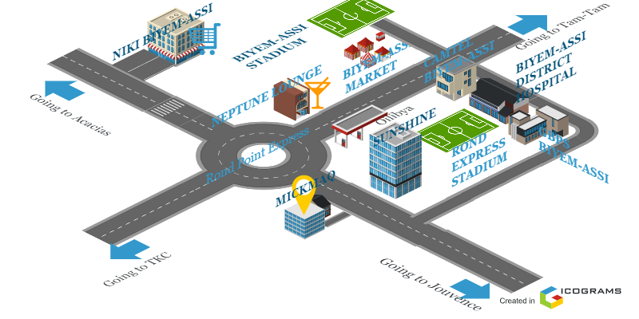

**Figure 1:Geographical location of MICKMAQ**

## **ADMINISTRATIVE ORGANIZATION.**

1. **Graphics Design and Development Department in charge of:**

* Elaborating terms of reference for clients
* Market estimates for software demand
* Analyzing and designing IT project
* Creating graphics designs for clients

1. **Sales and Accounting Department in charge of:**

* Commercializing Products
* Publishing Goods and services
* Selling goods and services
* Managing stock input and output
* Producing balance sheet

1. **Maintenance Department in charge of:**

* Diagnosing hardware problems
* Maintaining software and hardware

1. **System and Network Department in charge of:**

* Elaborating terms of reference to client
* Making estimates
* Network installations and Troubleshooting

**ABOUT**

### **Realizations**

The table below highlights some software developed by MICKMAQ

**Table 1: Some software applications developed by MICKMAQ**

Table 1:Some software application

|  |  |  |
| --- | --- | --- |
| NAME | TASKS | PRODUCTS |
| E-COMMERCE | It is an application used for buying products online |  |

## **ORGANIZATIONAL CHART AND RESOURCES OF MICKMAQ**

### **Organizational chart**

Below is the flow chart of MICKMAQ. As far as we are concerned, we are located at the Graphics Design and Development Department.

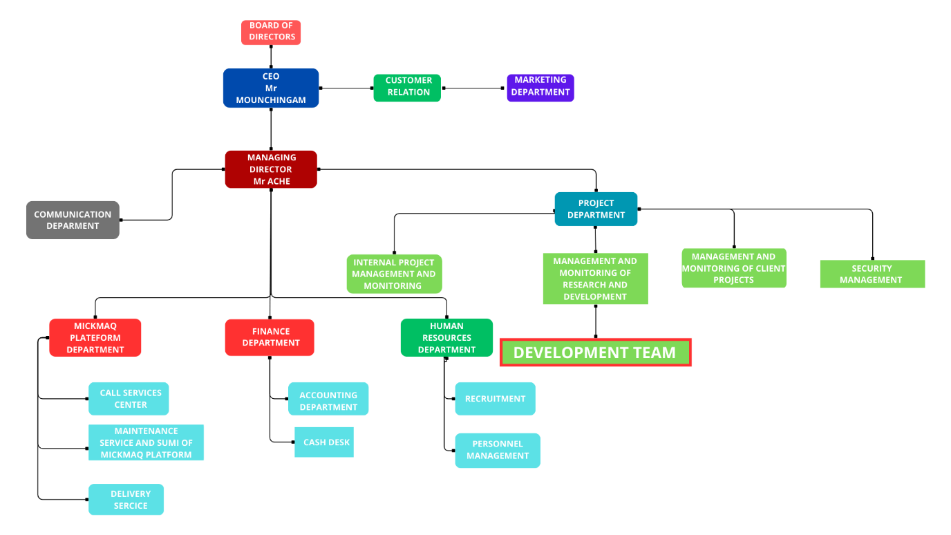

Figure 2: Organizational chart and resources of MICKMAQ

* + - 1. HARDWARE AND SOFTWARE RESOURCES OF THE COMPANY
* **HARDWARE RESOURCES**

The main activity of MICKMAQ is the building of software to that aim they use a verity of instruments like computers (laptop and desktops), Network modem, telephone, printers etc.

Table 2: Hardware resources of MICKMAQ.

|  |  |  |
| --- | --- | --- |
| EQUIPMENT | MARK | number |
| Laptops | Hp Pavillion | 03 |
| Printer | LG | 01 |
| Modem | Camtel | 01 |
| Phone | Google pixel | 01 |

* **SOFTWARE RESOURCES**

With regards to software resources, MICKMAQ has several software allowing them to perform various daily tasks.

Table 3: Software resources of MICKMAQ.

|  |  |
| --- | --- |
| DESIGNATION | SOFTWARE |
| Operation system | Windows 10, Mac OS, parrot Linux |
| Integrated development environment (IDE) | Visual studio code, Intellij |
| Text editor | Microsoft word |
| Database management system (DBMS) | MongoDB, PostgreSQL, MySQL |
| Web browser | Google chrome, Microsoft edge |
| Document editor | Microsoft office word |
| Presentation | Microsoft office PowerPoint |

## CONCLUSION

In conclusion, the theme “**Conception and Realization of a Digital Platform for Professional Connections and Opportunities in Cameroon**” presents a unique opportunity to revolutionize the job market in Cameroon by digitizing and modernizing traditional recruitment methods. By integrating features such as AI-powered job recommendation, personalized career guidance, skill assessment tools, and real-time communication for job seekers and employers, RiodusLink aims to streamline the hiring process for employers while offering job seekers tailored opportunities for career growth. Ultimately, this innovative project, developed during our internship at MickMack under the guidance of Mr.Fouapon Hassan, addresses the growing need for efficiency and personalization in the employment sector, bridging the gap between outdated recruitment practices and advanced digital technology.

# PART TWO: TECHNICAL PHASE

# BOOK ONE: EXISTING

Preamble

The existing system is a document that provides a view of the system currently in place, that is how it carries out its different activities, also it provides a deep understanding of this system associated to the various limitations, the problems that result from these and the solution we propose.

Content overview

INTRODUCTION

1. PRESENTATION OF THE THEME
2. STUDY OF THE EXISTING
3. CRITISISM OF THE EXISTING
4. PROBLEMATICS
5. PROPOSED SOLUTION

CONCLUSION

## INTRODUCTION

The existing system refers to the system put in place to carry out the work done in the field on which our theme is based. Understanding this system is a great step in solving the problems that we might identify. It's of great importance that we take into consideration this old system before proposing a suitable solution

BRIEF PRESENTATION OF THE PROJECT THEME

Our chosen theme is: **Conception and Realization of a Digital Platform for Professional Connections and Opportunities in Cameroon**. In today’s competitive and fast-evolving job market, many job seekers in Cameroon face challenges in building professional connections and accessing the right opportunities due to lack of visibility, inefficient application processes, and limited access to relevant information. The traditional methods of job hunting and networking, relying on word-of-mouth, printed CVs, and in-person visits, are increasingly outdated and often ineffective in a digitally connected world. To address this issue, we have developed RiodusLink, an intelligent job search and career management platform designed specifically to streamline and modernize the job-seeking experience and foster professional connections. The platform leverages AI-powered job recommendation algorithms to connect job seekers with opportunities and professional networks that align with their skills, qualifications, and interests. It also provides features such as remote applications, appointment booking for interviews, progress tracking, and employer communication, making the entire job application and networking journey more efficient and personalized. RiodusLink also benefits recruiters and employers by helping them identify ideal candidates quickly through intelligent filtering and data-driven recommendations, while facilitating connections within professional communities. This project, developed during our internship at MickMack under the guidance of Mr. Foupon Hassan, ultimately aims to close the gap between job seekers and employment opportunities and enhance professional connections by making the hiring and networking processes more transparent, accessible, and technology-driven, particularly for the Cameroonian context and beyond.

### DESCRIPTION OF THE EXISTING SYSTEM

The current job search and recruitment process largely relies on traditional, manual methods that are often inefficient and fragmented. Job seekers and employers face several challenges due to the lack of integrated digital tools tailored to streamline these processes. Below is a detailed overview of how the existing system operates:

1. **Job Seeker Profile Management:**  
   Job seekers typically manage their resumes, qualifications, and application history manually or across multiple disconnected platforms. This often leads to inconsistent records, lost data, and difficulty in updating information efficiently.
2. **Job Application Process:**  
   Applications are usually submitted via email, physical documents, or through multiple job boards without synchronization. This results in a scattered process where tracking the status of multiple applications becomes challenging and prone to errors.
3. **Job Tracking and Follow-up:**  
   Most job seekers rely on memory or personal notes to track job openings they have applied for, upcoming interviews, or follow-up deadlines. This manual system increases the risk of missing important dates or neglecting promising opportunities.
4. **Communication with Employers:**  
   Communication often occurs through emails, phone calls, or various messaging platforms, leading to inconsistent and sometimes delayed exchanges. This fragmented communication can cause misunderstandings and lost opportunities.
5. **Interview Scheduling:**  
   Scheduling interviews is frequently done informally by phone or email, lacking a centralized system to efficiently coordinate availability. This can result in scheduling conflicts, missed interviews, or last-minute cancellations.
6. **Job Listing and Filtering:**  
   Job seekers often face difficulties in filtering relevant job offers from numerous listings scattered across multiple sites. Employers may struggle to reach the right candidates without efficient filtering or matching tools.
7. **Candidate Experience:**  
   The traditional recruitment process can be frustrating for job seekers due to lack of transparency, delayed feedback, and inefficient application management, leading to dissatisfaction and decreased engagement.
8. **Scalability and Efficiency Challenges:**  
   Employers and recruiters managing large volumes of applicants face challenges in organizing and filtering candidate data without automation. Similarly, job seekers juggling multiple applications lack tools to optimize their job search efficiently, hindering scalability and effectiveness.
9. **Limited Professional Networking:**In Cameroon, job seekers often rely on personal contacts or informal networks for job leads, which limits access to broader professional connections. The absence of a digital platform to facilitate structured networking hinders collaboration and visibility within professional communities.
10. **Lack of Intelligent Matching:**  
    The existing system lacks AI-driven job recommendation tools, forcing job seekers to manually search for opportunities and employers to sift through unqualified applicants. This results in missed matches and inefficiencies in connecting the right candidates with suitable roles.

### LIMITS OF THE EXISTING SYSTEM

Table 3:Criticism of the existing system

|  |  |  |
| --- | --- | --- |
| CRITICISMS | LIMITS | PROPOSE SOLUTION |
| Manual management of job seeker profiles and resumes across multiple platforms leads to inconsistencies and lost information. | - No centralized database for **job seeker** profiles in Cameroon. - Difficulties maintaining up-to-date application records. - Risk of losing important candidate data over time. | Implement a centralized digital profile management system in **RiodusLink**, where **job seekers** can create, update, and store resumes, preferences, and application history in one secure platform. |
| Job applications submitted through email or multiple job boards result in scattered and untracked processes. | - Lack of unified application tracking for **job seekers**. - Difficulty following up on application status. - High chance of missing deadlines or interview invites. | Develop an integrated application tracking system in **RiodusLink** that allows **job seekers** to monitor all application statuses in real-time and receive timely notifications. |
| Scheduling interviews manually via phone or email causes conflicts and missed opportunities. | - No centralized interview scheduling tool in Cameroon’s job market. - Overlapping or missed interview appointments. - Poor coordination between **job seekers** and **employers**. | Build an online interview scheduling system in **RiodusLink** that synchronizes availability with automated reminders to reduce no-shows for **job seekers** and **employers**. |
| Communication between job seekers and employers is fragmented across different channels, causing delays and miscommunication. | - Informal and scattered communication methods in Cameroon. - No centralized messaging history. - Risk of misinterpretation and missed updates. | Introduce an in-app messaging platform in **RiodusLink** to streamline communication, ensuring all exchanges between **job seekers** and **employers** are tracked and accessible. |
| Job seekers have difficulty filtering and finding relevant job listings amidst overwhelming and unorganized postings. | - Lack of effective job filtering and **job recommendation** tools. - Users overwhelmed by irrelevant listings. - Reduced chances of matching suitable jobs in Cameroon. | Implement smart filtering and **AI**-powered **job recommendation** systems in **RiodusLink** based on **job seeker** profiles, skills, and preferences to present relevant opportunities. |
| Limited tools for building professional connections hinder networking opportunities in Cameroon’s job market. | - Reliance on informal networks limits access to broader professional communities. - Lack of digital platforms for structured networking. - Reduced visibility for **job seekers** and **employers**. | **Develop a networking module in RiodusLink to connect job seekers, employers, and professionals, enhancing collaboration and visibility** |

### PROBLEMATIC

With the description of the current professional networking and job search landscape in Cameroon clearly established, we can now formulate the central problem that our project seeks to address: **“HOW CAN WE DEVELOP A DIGITAL PLATFORM THAT FACILITATES PROFESSIONAL CONNECTIONS, STREAMLINES OPPORTUNITY DISCOVERY, AND ENHANCES ACCESS TO CAREER-RELATED RESOURCES FOR USERS IN CAMEROON?”** This key question guided the development of **RiodosLink** and was addressed through a set of reliable and efficient digital solutions presented in the subsequent sections. These solutions aim to overcome the fragmentation, communication gaps, and inefficiencies in traditional professional networking methods—making career development, opportunity discovery, and professional interactions smarter, faster, and more user-friendly within the Cameroonian context.

### PROPOSED SOLUTION

1. **Centralized Job Seeker Profile Management**  
   Develop a digital system where users can create and manage their professional profiles, upload resumes, specify job preferences, and store application history. This reduces the inefficiencies of managing information across multiple platforms and ensures easy access to updated records.
2. **Smart Job Application Tracker**  
    Implement a smart dashboard that allows users to track the status of each job application in real-time—from submission to interview and offer stages. This promotes transparency and helps job seekers stay organized throughout the job search process.
3. **Online Appointment Scheduling with Recruiters**  
    Build an integrated scheduling tool that enables job seekers to book consultation or interview appointments with recruiters. The system synchronizes with calendars and sends automated reminders, improving time management and reducing missed opportunities.
4. **In-App Communication System**  
    Provide a messaging platform within the application that facilitates direct communication between job seekers and employers or career advisors. This feature ensures clear, centralized conversations, reducing the risk of miscommunication or lost messages.
5. **Career Profile History and Analytics**  
    Introduce a system that maintains each user's career journey—tracking job types applied to, match scores, response rates, and interview feedback. This allows for more personalized job recommendations and empowers users to make data-driven career decisions.

### DELIMITATIONS OF THE FIELD OF STUDY

**• Account Management:**

User Registration: Job seekers and employers can register on the RiodusLink platform to create personalized accounts.

* Account Deletion: Users have the flexibility to delete their accounts at any time if they no longer wish to use the platform.
* Secure Logout: A secure logout function ensures user data privacy and account protection.

**• Job Application Management:**

* Job seekers can submit applications to various job postings and monitor the progress of each one through their dashboard.
* All submitted applications are stored for future reference, allowing users to build a comprehensive application history.

**➢ ADMIN**

* **Employer Account Management:**

Admins oversee employer accounts, including verification, activation/deactivation, and monitoring for platform compliance.

**• Application and Interview Oversight:**

Admins monitor the overall flow of job applications and scheduled interviews to ensure smooth platform operations**.**

**• Notifications and Communication:**

Admins can send push notifications to job seekers and employers regarding new job listings, interview reminders, system updates, or special announcements**.**

Conclusion

To conclude this section, we analyzed the traditional job search system by evaluating common practices and their limitations. From this study, we identified key challenges faced by users, including disorganized application tracking, inconsistent communication, and inefficient scheduling. Based on these insights, we proposed a modern digital solution in the form of a web application, **RiodosLink**, designed to address these issues. This step was crucial for understanding the weaknesses of the current system and guided the design of a platform that meaningfully enhances the professional networking and job search experience for both candidates and employers in Cameroon.

# 

# BOOK TWO:

# SPECIFICATION PHASE

Preamble

The existing system is a document that provides a view of the system currently in place, that is how it carries out its different activities, also it provides a deep understanding of this system associated to the various limitations, the problems that result from these and the solution we propose.

Content overview

INTRODUCTION

1. CONTEXT AND JUSTIFICATION
2. OBJECTIVES OF THE PROJECT
3. EXPRESSIONS OF NEEDS
4. TARGET POPULATION AND BENEFICIARIES
5. ESTIMATED COST OF THE PROJECT
6. ESTIMATED OF TIME REQUIRED
7. CONSTRAINT
8. LIST OF PARTICIPANTS AND DELIVERABLES

CONCLUSION

## INTRODUCTION

The specification book of our reports helps us provide details about our theme, to improve our understanding of it and increase the likelihood of it succeeding. To delimitate the scope of our project, we will specify the context of our theme. From the context, we will list the problems we have identified in our context and that we have decided to address throughout the project. After presenting our solution, we will talk about the objective we have set for ourselves for the project. Also, we will explore the needs to which our system will respond both at the functional and non-functional level. We will then look at the estimated financial requirements for our project, and establish a plan we will follow to complete our project on time. From here we will discuss what is expected of us by the end of the project under the project deliverables

#### CONTEXT AND JUSTIFICATION

#### Context

Professional networking and opportunity discovery are critical phases in every individual’s career journey. Traditionally, these processes have relied on fragmented methods such as physical resumes, word-of-mouth recommendations, notice boards, and scattered job listings across multiple platforms. This fragmented approach creates challenges for both professionals and employers. Job seekers often struggle to discover relevant opportunities, track their applications, or connect with the right industry contacts. Employers, meanwhile, face inefficiencies in filtering applicants, managing candidate data, and identifying suitable talent.

In today’s digital-first world, expectations for professional development and recruitment have shifted. Users now demand platforms that are not only intuitive but also intelligent, capable of recommending opportunities and fostering professional connections tailored to their skills and career goals. Employers seek tools that streamline the recruitment process, reduce manual effort, and provide data-driven insights for decision-making. Unfortunately, most existing systems remain siloed, lacking integration, automation, and networking features, which results in missed opportunities and fragmented professional interactions.

To address these challenges, the development of **RiodosLink** has been proposed. RiodosLink is a web-based digital platform designed to facilitate both professional connections and career opportunities in Cameroon. By integrating smart opportunity matching, real-time tracking of applications, centralized communication, and connection-building features, the platform empowers users to expand their professional networks while efficiently managing their career paths. RiodosLink thus bridges the gap between job seekers, employers, and professional networks, ensuring a faster, smarter, and more connected professional ecosystem.

.

#### Justification

The development of the **RiodosLink** platform provides significant value to professionals, employers, and the broader networking ecosystem in Cameroon:

1. **Efficiency:** Users can create comprehensive professional profiles, showcase skills, upload resumes, and apply to opportunities without repetitive form-filling. Employers benefit from a streamlined candidate management system that allows them to post jobs, filter applicants based on qualifications and match scores, and automate parts of the recruitment and networking process. This reduces administrative workload and accelerates professional engagement.
2. **Accessibility:** RiodosLink enables users to explore career opportunities and connect with relevant professionals from anywhere, at any time. This flexibility removes geographic barriers, ensures opportunities are within reach, and allows employers to access a wider pool of talent and potential collaborators.
3. **Enhanced Interaction:** Integrated features such as real-time application tracking, direct messaging, appointment scheduling, and networking suggestions strengthen communication and collaboration between users. This leads to quicker feedback, fewer missed opportunities, and more meaningful professional connections.
4. **Data Organization and Personalization:** RiodosLink securely maintains users’ career histories, preferences, applications, and connection patterns, enabling tailored recommendations for jobs and networking opportunities. Employers benefit from structured, easy-to-access candidate data that supports informed decision-making and targeted outreach.

Ultimately, **RiodosLink** bridges the gap between traditional job search and networking methods and modern digital expectations. By leveraging intelligent algorithms, real-time data, and an intuitive interface, the platform makes professional development, opportunity discovery, and networking more efficient, transparent, and user-centric.

#### OBJECTIVES OF THE PROJECT

#### General Objective

To design and implement **RiodosLink**, an intelligent and user-friendly digital platform that facilitates professional connections, career opportunities, and efficient recruitment in Cameroon, while supporting continuous professional development and networking.

#### Specific Objectives

a. Develop a smart opportunity and professional matching engine using AI algorithms to recommend jobs and potential connections.  
b. Enable employers and recruiters to post, manage, and track job offers seamlessly.  
c. Provide users with tools such as CV/resume builders, career analytics, skill tracking, and progress monitoring.  
d. Include a calendar-based scheduling system for interviews, professional consultations, and networking appointments.  
e. Create integrated messaging and chat systems to facilitate communication between candidates, employers, and other professionals.  
f. Implement notifications (push/email) for job alerts, application updates, interview reminders, and connection requests.  
g. Provide an admin interface to oversee platform activity, monitor user behavior, manage content, and ensure compliance with platform rules and data privacy standards.

#### EXPRESSION OF NEEDS

#### Functional Needs

Functional needs refer to the specific capabilities and features that **RiodosLink** must provide to meet the requirements of its primary users — job seekers, employers, and administrators. These functionalities are essential to ensure a smooth and effective user experience across professional networking, job applications, and recruitment processes. **User Registration and Authentication**: The platform must support secure account creation and login for different user roles:

1. **User Registration and Authentication:**  
   The platform must support secure account creation and login for different user roles:

* **Job Seekers:** Register, log in, and manage personal profiles, resumes, and applications.
* **Employers/Recruiters:** Create and manage company profiles, post jobs, and review applicants.
* **Admins:** Oversee platform activity, verify accounts, and maintain security and integrity.

1. **Profile Management:**

* **Job Seekers:** Update and manage personal details, educational background, work experience, skills, certifications, and upload CVs/resumes or portfolios.
* **Employers/Recruiters:** Manage company profiles, job listings, and view candidate engagement statistics.
* **Admins:** Monitor and modify user profiles when necessary for compliance, moderation, or troubleshooting.

1. **Job Posting and Discovery:**

* **Employers/Recruiters:** Post detailed job listings with descriptions, qualifications, deadlines, and locations.
* **Job Seekers:** Search, filter, and browse job listings by categories such as industry, location, salary, experience, and skills.
* **AI Suggestions:** Intelligent recommendations for jobs or professional connections based on the user’s profile, past applications, and interactions.

1. **Interview Scheduling and Calendar Management:**

* Integrated calendar module to schedule interviews, networking meetings, or professional consultations.
* Notifications and reminders for upcoming appointments.
* Support for in-app meeting links or integrations with virtual meeting tools (e.g., Zoom, Google Meet).

1. **Application and Opportunity Management:**

* **Job Seekers:** Apply for jobs, track application status (e.g., pending, shortlisted, rejected), and receive interview updates.
* **Employers/Recruiters:** View applicant profiles, filter candidates by criteria, and update application statuses.

1. **Messaging and Communication System:**

* In-app messaging to facilitate direct communication between job seekers, employers, and professional contacts.
* Centralized conversation history to ensure clarity and prevent information loss.

1. **Notification System:**

* Real-time and scheduled notifications for job postings, application updates, interview reminders, messages, and platform alerts.
* Support for email, push notifications, and in-app alerts.

1. **Reporting and Analytics:**

* Analytics dashboards to monitor platform engagement, application trends, and connection activity.
* Personalized insights for job seekers (e.g., application success rate) and employers (e.g., candidate engagement statistics) to aid decision-making.

#### Non-Functional Needs

Non-functional needs refer to the system's overall performance, usability, and operational requirements. These address how the system should perform rather than what it should do.

1. **Scalability**: The platform must be designed to scale smoothly as the number of users grows including thousands of job seekers, recruiters, and job postings without negatively impacting system performance or user experience.
2. **Security**: It must ensure robust security mechanisms to protect sensitive data such as personal details, resumes, employer credentials, and payment information. All data should be encrypted in transit and at rest. Role-based access control and multi-factor authentication should be implemented to prevent unauthorized access.
3. **Reliability**: The system must be reliable and available at all times, with minimal downtime. A reliable backup system should be in place to prevent data loss.
4. **Performance**: The platform should have fast loading times, quick response to user inputs, and efficient data processing to ensure a smooth user experience.
5. **Cross-Platform Compatibility**: The platform should be compatible with various devices and operating systems, including web browsers, Android, and iOS devices.
6. **User-Friendly Interface**: The UI/UX should be intuitive and clean, catering to users with different technical proficiencies. Clear navigation, consistent styling, and meaningful feedback (e.g., success/failure messages) should help users easily complete tasks like applying for jobs, posting listings, or updating profiles.
7. **Accessibility**: The platform should be accessible to all users, including those with disabilities, by following web accessibility standards (e.g., WCAG 2.1).
8. **Maintainability**: The codebase should be well-documented and modular, allowing for easy updates, bug fixes, and feature additions.

#### TARGET POPULATION AND BENEFICIARIES

**Job Seekers:**

* **Primary Users:** Individuals actively seeking professional opportunities in Cameroon, including students, recent graduates, professionals in transition, and freelancers.
* **Key Benefits:**

1. Access to a wide range of verified job postings relevant to the local job market.
2. Personalized job and professional connection recommendations based on skills, experience, and career goals.
3. Tools to create, manage, and share digital resumes/CVs and professional profiles.
4. Ability to apply directly to job offers, track application status in real-time, and receive feedback.
5. Career development support, including skill assessments, certifications, interview preparation, and mentorship opportunities.

**Recruiters and Employers:**

* **Primary Users:** HR managers, recruiters, and organizations looking to post job offers, identify qualified candidates, and manage hiring pipelines efficiently.
* **Key Benefits:**

1. Ability to post targeted job openings and reach the most suitable candidates.
2. Access to a rich database of candidate profiles with advanced search, filtering, and recommendation tools.
3. Streamlined communication with applicants and professional connections through the platform’s messaging system.
4. Tools to manage interviews, track recruitment processes, and improve hiring efficiency.
5. Analytics dashboards to monitor recruitment metrics, optimize strategies, and identify talent trends in Cameroon.

**Platform Administrators:**

* Ensure platform security, moderation, and compliance.
* Monitor activity to maintain an efficient, fair, and user-friendly environment for all participants.

### ESTIMATED COST OF PROJECT

#### Hardware Resources

Table 4 Hardware Resources of the project (Source: Mercurial 2023-2024)

|  |  |  |  |  |
| --- | --- | --- | --- | --- |
| RESOURCES HARDWARE USAGE QUANTITY | | | | UNIT COST (FCFA) |
| Computer | Hp, 16GB RAM, 1.25 TB Hard Drive;  intel core i5 | Report writing and editing,  analysis, coding | 1 | 400000 |
| Removable  Drive | 16GB USB key | For file  transferring  from one computer to  another | 1 | 8500 |
| Modern | Hawai | For the downloading of resource and achievement of information | 30000 | 30,000 |
| TOTAL 1 |  |  |  | **438 500** |

#### Software Resources

Table 5:Software ressources (source: Mercurial 2023/2024)

|  |  |  |  |  |
| --- | --- | --- | --- | --- |
| RESOURCES SOFTWARE | | USAGE | QUANTITY | UNIT COST (FCFA) |
| Development  tool | Visual Studio  Code | Code Editing | 1 | Open Source |
| Database  Management  System | SQL | Communication  with the  database | 1 | Open Source |
| Operating  System | Microsoft  Window 10 pro | Computer  Operating  System | 1 | 126 000 |
| Project Planner | Gantt Project | Project Planning  Tool | 1 | Free Software |
| Text Editor | Microsoft  Office Pro 2016 | For writing and structuring the internship report | 1 | 161 000 |
| Modelling Tool | Visual Paradigm | Modelling the system in UML | 1 | 439 450 |
| TOTAL 2 |  |  |  | **726 450** |

#### Human resources

Table 6:Software resources (source: Mercurial 2023/2024)

|  |  |  |  |  |
| --- | --- | --- | --- | --- |
| RESOURCES | NUMBER | COST PER DAY | NUMBER OF DAY | COST (FCFA) |
| Project  Manager | 1 | 70000 | 70 | 4 900 000 |
| Analyst | 1 | 30000 | 31 | 930 000 |
| Designer | 1 | 40000 | 30 | 1 200 000 |
| Programmer | 1 | 30000 | 30 | 900 000 |
| TOTAL 3 |  |  |  | **7 930 000** |

#### Total Project Estimation

Table 7: Total project Estimated cost

|  |  |
| --- | --- |
| Designation | Cost (FCFA) |
| Human Resources | **7 930 000** |
| Software Resources | **726 450** |
| Hardware Resources | **430,500** |
| Unforseen | 900,000 |
| TOTAL | **10,132 788** |

### ESTIMATION OF TIME REQUIRED

|  |  |  |  |  |
| --- | --- | --- | --- | --- |
| PHASE OBJECTIVE | | OUTPUT | DURATION | PERIOD |
| Insertion | Welcome and integration in the company and attribution of internship themes. | Insertion  Report | 6 days | 01st to 08th July  2025 |
| Specification | Description of project functionalities | Specification book | 4 days | 08th to 11th July 2025 |
| Analysis | Analysis of the system | Analysis  Book | 5 days | 14st July to 18th  July 2025 |
| Conception | Hardware and software conception, | Conception  Book | 4 days | 18th July to 22th July  2025 |
| Realization | Realization of the system | Realization document | 6 days | 22th July to 29th July  2025 |
| Deployment | Deployment of the  system | Running system | 6 days | 1st August to 8th  August  2025 |
| Writing user guide | Instruction and indication on how to use the software | User guide | 4 days | 9st August to 12th  August  2025 |

This activity consists of determining tasks and putting them in order by presenting them in interval of time. We will present it on a table and a Gant diagram.

Table 8: Estimation of required time for the project

We have a period of three months to carry out our project. Project planning helps us schedule the different task of the project to permit the successful and on-schedule realization of the project. We made use of a timing activity and Gantt chart to illustrate the various tasks for our project. We will execute the tasks successively, with each task commenced upon the completion of its predecessor*.*

GANTT CHART

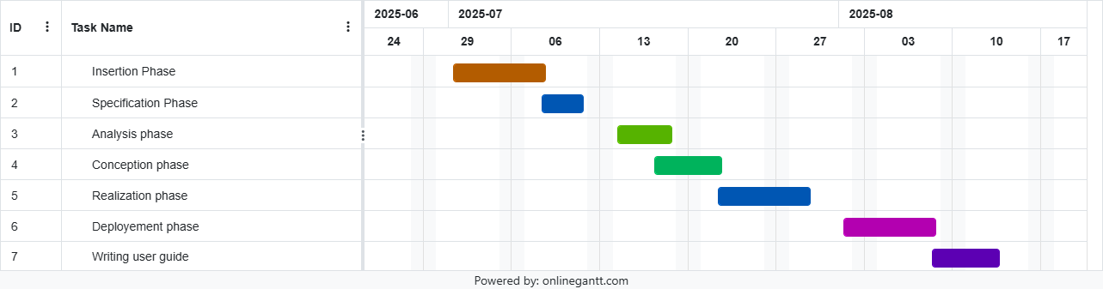

Table 9:Gantt chart

### CONSTRAINTS

#### Technical constraint

For the development of our system, we have sufficiently robust tools to guarantee a minimum of security, extensibility and excellent scalability. Moreover, the programming phase will have to follow all the technical standards for a better performance in a reduced execution time, this is why the choice of the development technologies is crucial.

#### 2. Time Constraint

The project will be realized in 14 weeks starting from the beginning date coupled with many other school projects.

#### 3. Cost constraint

The realization of our project will require expenditures in human resources, material and software for a total of **10,132 788 FCFA**.

### LIST OF PARTICIPANTS AND DELIVERABLES

#### List of participants

|  |  |  |
| --- | --- | --- |
| Name Title Role | | |
| Mr. FOUAPON HASSAN | Software Engineer | Professional Supervisor |
| Mr. NDENGE | Lecture at AICS-Cameroon | Academic Supervisor |
| NGATSING TAKAM FRANCK ARTHUR | Software Engineering  Student at AICS-Cameroon | Analyst and Developer |

Table 10:Project participants

#### Deliverables

In project management, any component materializing the result of a realization.

At the end of this project, we are expected to submit the following;

A complete report containing

* Insertion Book
* Specification Book
* Analysis Book
* Conception Book
* Realization Book
* Software Setup
* User’s guide

## CONCLUSION

Having completed the specification phase of RiodosLink, we successfully defined the project’s scope, established its context, and justified its relevance in enhancing professional connections and opportunities in Cameroon. We identified the platform’s objectives, outlined the functional and non-functional needs, estimated project costs, and specified the target users and deliverables. With these goals met, we have laid a solid foundation to move into the analysis phase, where we will examine existing systems, identify gaps, and model RiodosLink using appropriate methodologies to ensure it effectively addresses user requirements.

# BOOK THREE:

# ANALYSIS PHASE

Preamble

After specification book, we have the Analysis phase which permits us to  
represent a detailed analysis of the limitations identified in our context, and our  
solution, through a software development process and modelling language.

Content overview

INTRODUCTION

1. PRESENTATION OF THE ANALYSIS APPROACH
2. MODELLING OF THE PROPOSEDSOLUTION

CONCLUSION

## INTRODUCTION

As engineers, our primary role in society is problem-solving, aimed at improving efficiency and making life easier for everyone. To develop an effective solution, we must first ask critical questions: why does the problem exist, and how is it currently being addressed? Often, there is an existing system in place, but it may be inefficient, outdated, or unable to fully meet users’ needs. In such cases, we must decide whether to create a completely new system or improve the existing one. Regardless of the chosen approach, a thorough study and understanding of the system’s functioning is essential to ensure that the proposed solution provides meaningful benefits. System development typically involves two major components: system analysis and system design. System analysis focuses on understanding the details of the current system, identifying gaps, proposing a new or improved system, and evaluating whether the proposed solution is desirable, feasible, and capable of meeting the users’ needs effectively. In this context, our project, **RiodosLink**, seeks to design and implement a digital platform that enhances professional connections and opportunities in Cameroon, offering intelligent tools for job seekers, recruiters, and administrators.

### PRESENTATION OF THE ANALYSIS METHOD

We studied multiple analysis methods in order to get a better orientation on which one to choose for our system. Below are some analysis methods we studied;

#### A. SOME ANALYSIS METHODS/APPROACH

1. ***MERISE*** *:* MERISE stands for “Méthode d’Etude et de Réalisation Informatique pour des Systèmes d’Entreprise”. Although it is prescriptive to some extent, MERISE permits the participation of end users and senior management as well as data processing professionals in its decision cycle. MERISE is a method for designing, developing and carrying out IT projects. The goal of this method is to achieve the design of an information system. The MERISE method is based on the separation of data and processing to be carried out in several conceptual and physical models. The essentials of the approach lie in its three cycles: the decision cycle, the life cycle and the abstraction cycle, which cover data and process elements equally. The separation of data and processing ensures longevity in model. Indeed, the arrangement of data does not have to be often overhauled, while treatments are more frequently.
2. ***SCRUM:*** In the agile Scrum world, instead of providing complete, detailed descriptions of how everything is to be done on a project, much of it is left up to the Scrum software development team. This is because the team will know best how to solve the problem they are presented. This is why in Scrum development, for example, a sprint planning meeting is described in terms of the desired outcome (a commitment to a set of features to be developed in the next sprint) instead of a set of Entry criteria, Task definitions, Validation criteria, exit criteria (ETVX) and so on, as would be provided in most methodologies. Agile scrum methodology is a project management system that relies on incremental development. Each iteration consists of two- to four- week sprints, where each sprint's goal is to build the most important features first and come out with a potentially deliverable product. More features are built into the product in subsequent sprints and are adjusted based on stakeholder and customer feedback between sprints.

1. ***UP:*** The UP is an abbreviation of Unified Process. It is an iterative and incremental software development methodology. The Unified Process is an iterative, architecture centric software development process driven by use cases and geared towards reducing risk. It is a process pattern that can be adapted to a wide class of software systems, to different areas of application, to different types of businesses, to different skill levels and to different sizes of the business. Different data. It qualifies a process or a procedure that performs a group of operations repeatedly until a well-defined condition is met.

##### *4.* **DYNAMIC SYSTEM DEVELOPMENT METHOD(DSDM):** It is an

organized, common-sense process focused on delivering business solutions quickly and efficiently rather than just team creativity. It is similar in ways to SCRUM and XP, but it has its best uses where the time requirement is fixed.

### CHOICE OF THE ANALYSIS APPROACH

#### Two Track Unified Process (2TUP)

2TUP is a unified process, that is, it is a software development process built on UML. The 2TUP brings an answer to the constraint of continual changes imposed by the information system of an enterprise. In this sense, it enforces the control on the capacity of evolution and correction of the system. The 2TUP offers a Y-shaped process that divides the technical aspects giving two branches, namely the functional branch and the technical branch, which justifies why it is a two-track process. These two branches finally merge into the realization branch for the implementation of the system. The figure below illustrates the 2TUP:

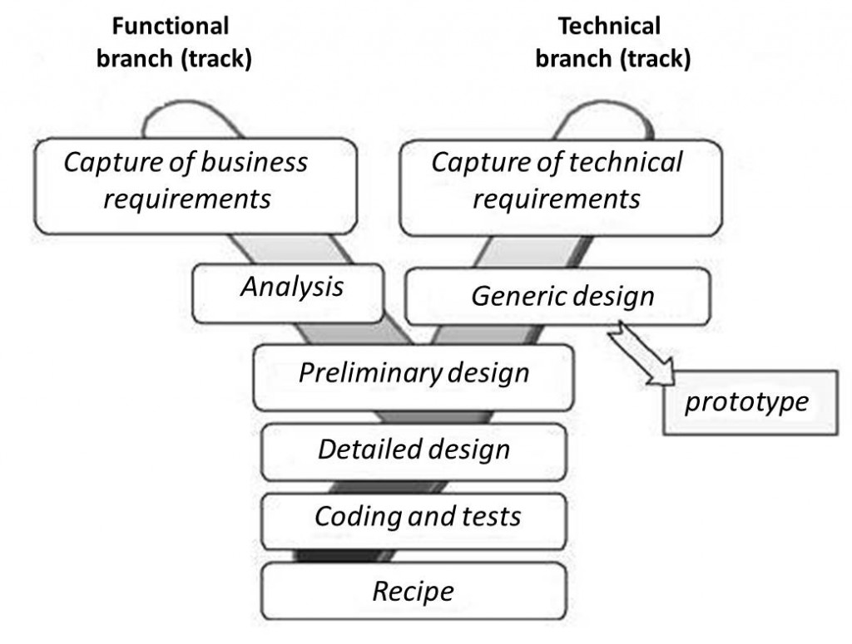

Figure 2: 2TUP Diagram (Source: www.memoireonline.com)

#### a) Functional Branch

The functional branch captures the functional needs of the system and analyse them. This phase specifies the elements of the preliminary study and does not depend on technology used to build the system.

#### b) The Technical Branch

The technical branch enumerates the technical needs and proposes a generic design validated by a prototype. The technical needs here include the tools, materials and technologies that will be used along with the different constraints such as worst-case scenario and integration with the existing controls.

#### c) Realization Branch

The realization track supports the following:

* The preliminary conception: This is the most sensitive step of the 2TUP. This is the meeting point between the functional and technical branches. It ends when the deployment model, the operating model, the logical model, interfaces and software configuration model are defined;
* The detail conception: This is the detailed design of each feature of the system;
* Coding and testing: This are the programming phase of the designed features, alongside testing of the coded features;
* The Recipe: This is the validation phase of the functions of the system developed

#### Modelling with UML 2.5

The 2TUP and UML work in close collaboration. Having already discuss briefly on 2TUP, UML being its foundation is not to be taken lightly. **UML** stands for **Unified Modelling Language**. It can be used to model a system independent of a platform language. UML is a graphical language for visualizing, specifying, constructing, and documenting information about software-intensive systems, some of which are object oriented. UML gives a standard way to write a system model, covering conceptual ideas, hence it is a privilege vector of communication between members of a team. Before proceeding, here are some key terms to understand:

**Model:** A model is an idealized, abstract and simplified representation of a real-world object or a simplified simulation of an entity.

**Why is UML Unified:** UML is said to be unified because it is a combination of three modelling approaches namely:

1. Object Modelling Technique (OMT) which provides a graphical representation of the static, dynamic and functional aspects of a system;
2. Booch approach which was excellent for design and implementation. It introduces the notion of packages;
3. OOSE (Object-Oriented Software Engineering) approach which focuses on design base on the user’s needs.

How is UML a language: The UML notations are a standard are widely in the professional milieu. The notations are a must, however the usage these notations in a software development approach are not, hence it is just a guide line.

UML 2.5 defines 14 diagrams that are classified into two main categories: Structural and Behavioural diagrams

#### a) Structural diagrams:

Structural diagrams show the static structure of the system and its parts on different abstraction and implementation levels and how they are related to each other. The elements in a structure diagram represent the meaningful concepts of a system, and may include abstract, real world and implementation concepts. In UML 2.5 there are seven types of structural diagrams as follows:

* Class diagram;
* Component diagram;
* Deployment diagram;
* Object diagram;
* Package diagram;
* Composite structure diagram;
* Profile diagram;

#### b) Behavioural diagrams

Behavioural diagrams show the dynamic behaviour of the objects in a system from the beginning of a task to its completion. Below are the behavioural diagrams in UML 2.5:

* Use case diagram;
* Activity diagram;
* State Machine diagram;
* Sequence diagram;
* Communication diagram;
* Interaction Overview diagram;
* Timing diagram

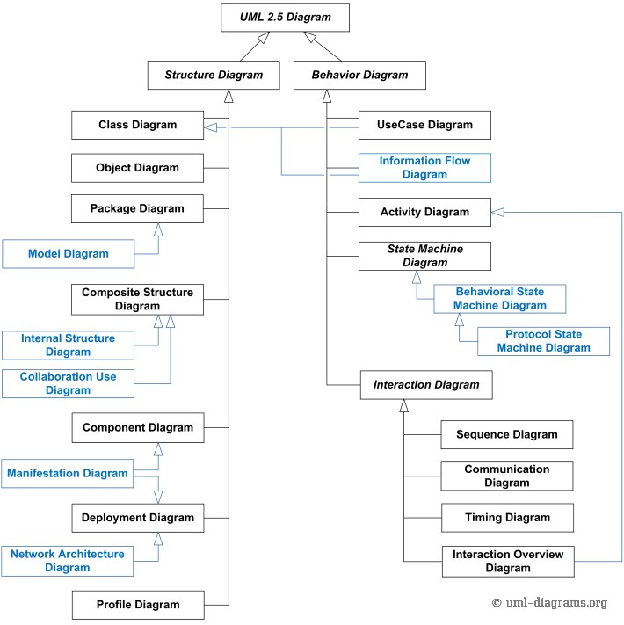

Figure 3: UML 2.5 Diagrams Overview (source: http://www.uml-diagrams.)

### VIII. MODELING OF THE PROPOSED SOLUTION

###### **Definition**

Use case diagram is a graphic depiction of the interactions among the elements of a system. A use case is a methodology used in system analysis to identify, clarify, and organize system requirements.

###### **Formalism**

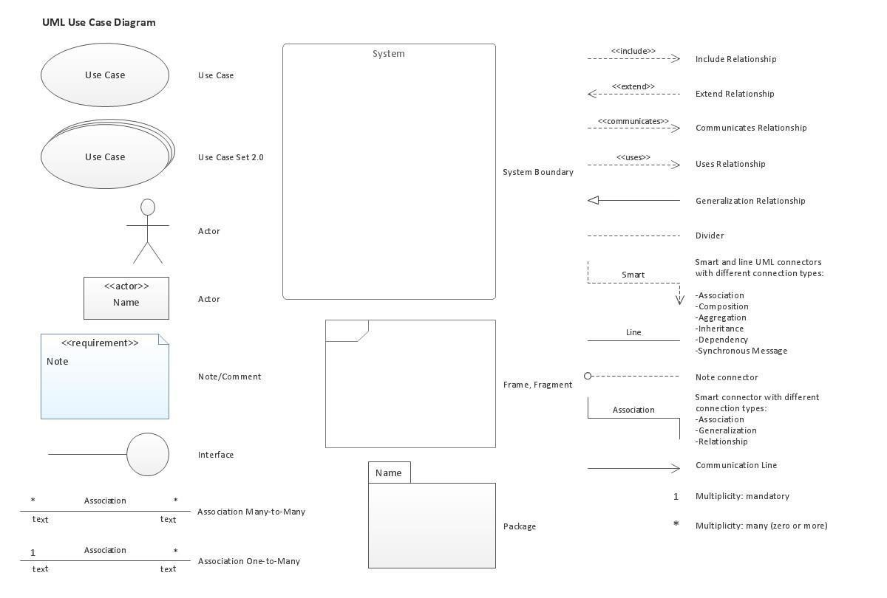

Figure 4: formalism of a Use Case diagram

The components of a use case diagram are illustrated below:

Table 11:Use case diagram components

1. Elements of a Usecase diagram

|  |  |  |
| --- | --- | --- |
| Elements Notation Description | | |
| Actors |  | Represents an entity that directly interacts with the system. The actor is what performs the different possible actions of the system. |
| Use case | Use Case  1 | A use case represents a functionality of the system. It is an action that can be performed by an actor. |
| Association |  | it indicates that an actor takes part in a use Case. |
| Include |  | An inclusion denotes that an included action must be performed before the including action can be performed. |
| Extend |  | An extension denotes that an extending action may be performed while an extended action is being performed. |
| Generalization |  | This shows that an actor or a use case is a kind of another abstract or concrete actors can be defined and later specialized using generalization relationship. |
| System |  | It is a container of use cases which interact with external actors |

*Table 14**:Use case diagram component*

**A. LIST OF ACTORS:**

* **Administrator or Super user:** The administrator is responsible for system administration of users and transaction.
* **Job seeker:** Thes are parties interacting with the application in order to benefit from the services.
* **Employer:** This is verified personnel who post job openings, view job applications

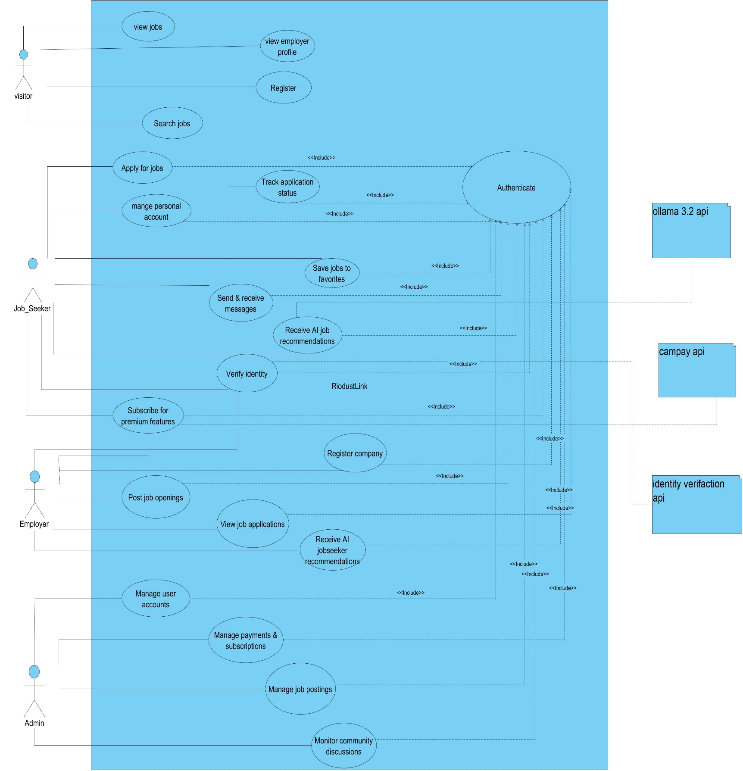USE CASE DIAGRAM: GENERAL USE CASE

Figure 3:General Use case

## Use case: Manage application

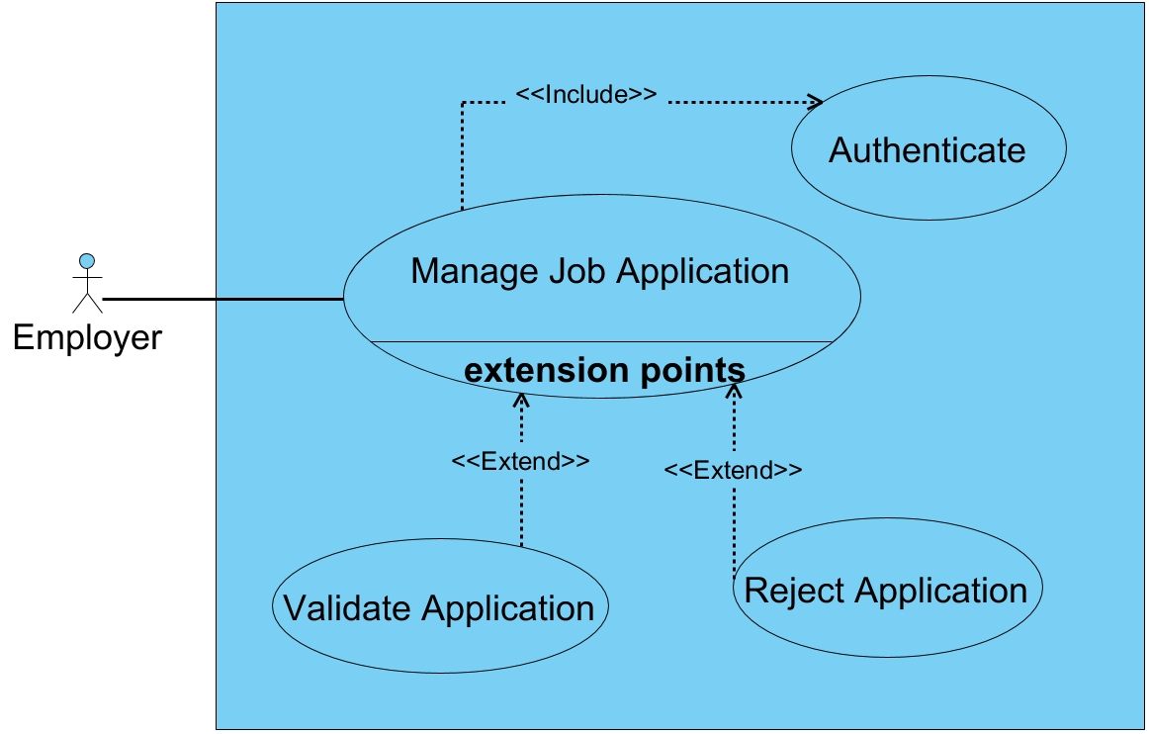

Figure 5:Use case Manage application

## Use case: Post Job Openings

Figure 6: Use case post job opening

## Use case: Apply for Jobs

Figure 7: Use case Apply for job

b) Textual description of use cases

UML allows the execution of a use case to be described in a textual way, in a form called nominal scenario. A nominal scenario describes in more detail the execution of a use case by an actor until it is successfully completed.

***Formalism***

A textual description of a use case is represented in the following form

Table 12: Formalism of Textual Description

|  |  |
| --- | --- |
| NAME OF THE USE CASE | |
| Actors | Users |
| Objective | Aim of the use case |
| Presuppose | Set of actions that must be completed before the launching of the use case |
| Post condition | Set of actions that must be completed before the launching of the use case |
| Triggers | Element that triggers the use case |
| Principal Scenario | Description of the principal scenario |
| Alternative Scenario | Descriptions of alternative scenarios (where the nominal scenario is a failure) |
| Post condition | Set of mechanism that can lead to the end of the use case |

TEXTUAL DESCRIPTION OF REGISTER/CREATE ACCOUNT

Table 13: Textual description for register/create account

|  |  |  |
| --- | --- | --- |
|  | USE CASE REGISTER | |
| Actors |  | Employer, Job Seeker |
| Objective |  | Grant the user’s access to the application |
| Precondition |  | The system is working properly |
| Triggers |  | The user launches the application |
| Principal Scenario |  | 1. Users click on the application Icon 2. The system displays an onboarding screen 3. After the onboarding screen the users click on get started. 4. The Application display the login page 5. The user clicks on register 6. The Application displays the Registration page 7. The user fills the empty field with his credential 8. The user clicks on register button 9. The application check whether the data format entries are correct 10. The application sends a request to the database server which execute it and return a response. 11. The application analysis the respond return by the database server 12. The user is directed to his page |
| Alternative Scenario |  | 9-a) If at step 7 of the principal scenario the data format is not correct, an error message is return to the user and he return to step 4 of the principal scenario  11-a) If at step 10 of the principal scenario a user was found during the verification, the system returns an error message and we return to step 4 of the principal scenario |
| Post condition of success |  | The user’s account is created and he access his page |
| Post condition of failure |  | An error message is display and user does not have access his space. |

##### TEXTUAL DESCRIPTION OF AUTHENTICATION

Table 14: Textual description of authentication

|  |  |
| --- | --- |
| USE CASE AUTHENTICATE | |
| Actors | Job seeker, Employer, Admin |
| Objective | Grant the user’s access to the application |
| Precondition | The user should have an active account |
| Triggers | The user launches the application |
| Principal Scenario | 1. Users click on the application Icon 2. The system displays an onboarding screen 3. After the onboarding screen the users click on get started. 4. The Application server display the login page 5. The user fills the empty field with his credential 6. The user clicks on login button 7. The application server check whether the data format entries is correct 8. The application server sends a request authentication to the database server which execute it and return a response. 9. The application server analysis the respond return by the database server 10. The users are directed to his page |
| Alternative Scenario | 7-a) If at step 7 of the principal scenario the data format is not correct, an error message is return to the user and he return to step 4 of the principal scenario  9-a) If at step 9 of the principal scenario no users were found during the verification, the system returns an error message and we return to step 4 of the principal scenario |
| Post condition of success | The users have access to his page |
| Post condition of failure | An error message is display and user does not have access his space. |

##### TEXTUAL DESCRIPTION OF MANAGE APPLICATION

Table 15: Textual description of Manage Application

|  |  |
| --- | --- |
| USE CASE MANAGE APPLICATION | |
| Actors | Employers |
| Objective | Review applications submitted by job seekers |
| Precondition | The user must be authenticated |
| Triggers | The recruiter clicks on the "View Applications" button |
| Principal Scenario | 1. The recruiter clicks on a job post from their dashboard. 2. The system displays a list of submitted applications for the selected job post. 3. The recruiter selects one application to review. 4. The system displays the detailed profile of the job seeker, including resume, cover letter, and any additional documents. 5. The recruiter selects an action and confirms. 6. The system processes the server response and updates the UI accordingly. |
| Alternative Scenario | 4-a) If no applications are found for the selected job post, the system displays a message: *"No applications submitted yet."* and returns to step 1.  6-a) If at step 6 of the principal scenario no user is found during the verification, the system returns an error message and we return to step 5 of the principal scenario |
| Post condition of success | The recruiter has successfully reviewed and taken action on the selected application, and the application status is updated accordingly. |
| Post condition of failure | An error message is display and user does not have access his space. |

## TEXTUAL DESCRIPTION OF Post Job Openings

Table 16: Textual description Post Job Openings

|  |  |
| --- | --- |
| USE CASE POST JOB OPENINGS | |
| Actors | Employer |
| Objective | Post a new job offer on the platform |
| Precondition | The recruiter must be authenticated (logged into their account). |
| Triggers | The recruiter clicks on the **“Post a Job”** button. |
| Principal Scenario | 1. The recruiter clicks on the **“Post a Job”** button from their dashboard. 2. The system displays the job posting form. 3. The recruiter fills in the job details (title, description, category, location, salary, requirements, etc.). 4. The system checks whether the data entries are correct 5. The recruiter submits the form 6. The system sends a request to the server, which executes and returns a response 7. The system processes the server response and updates the UI accordingly |
| Alternative Scenario | 4-a) If at step 4 of the principal scenario, the data format is not correct, an error message is returned to the user, and they return to step 3 of the principal scenario 6-a) If at step 6 of the principal scenario, no valid user is found during the verification, the system returns an error message, and the process returns to step 4 of the principal scenario |
| Post condition of success | The job posting is successfully published on the platform and is visible to job seekers. |
| Post condition of failure | An error message is displayed, and the job post is not published until corrected and resubmitted. |

#### b) Communication Diagram

##### Definition

Communication diagram model the interaction between objects in a sequence. A communication diagram is more focused on showing the collaboration of objects rather than the time sequence. Communication diagrams are especially good at showing which links are needed between participants to pass an interaction’s message.

##### Formalism

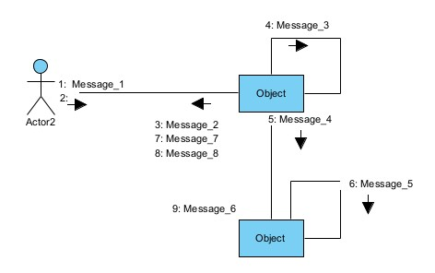

Figure 8: Formalism of a communication diagram

Table 17:Component of the Communication Diagram

|  |  |  |
| --- | --- | --- |
| Element | Representation | Description |
| Call Message |  | A call message defines a particular communication between lifeline of an interaction |
| Dependency |  | A dependency is a relationship that signifies that a single or set of model elements require other model elements for their specification |
| Object |  | An object represents an individual participant in the interaction conversion |
| Generalization |  | A generalization is a taxonomic relationship between a more general classifier and a more specific classifier. |

##### Authentication Communication Diagram

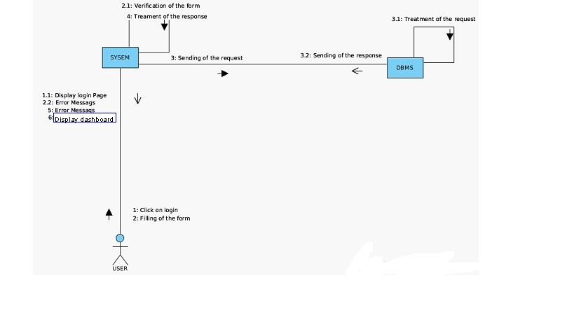

Figure 9: Authentication Communication Diagram

Post Job communication diagram

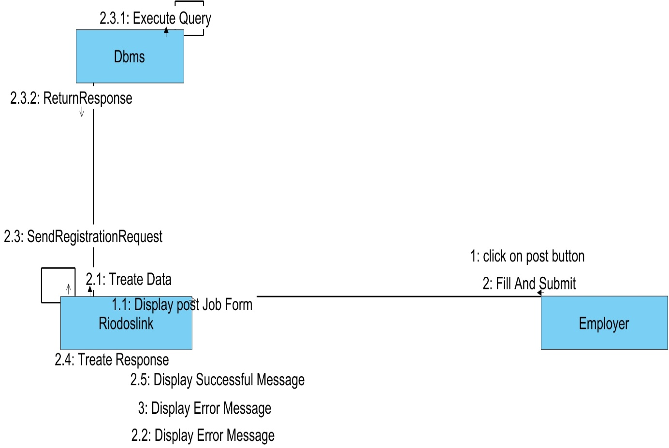

Figure 10 : Communication Diagram

#### c) Sequence Diagram

##### Definition

A sequence diagram is a diagram that shows the interaction details, and how operations are carried out. Sequence diagrams focus on the message interchange between a number of lifelines.

##### Formalism

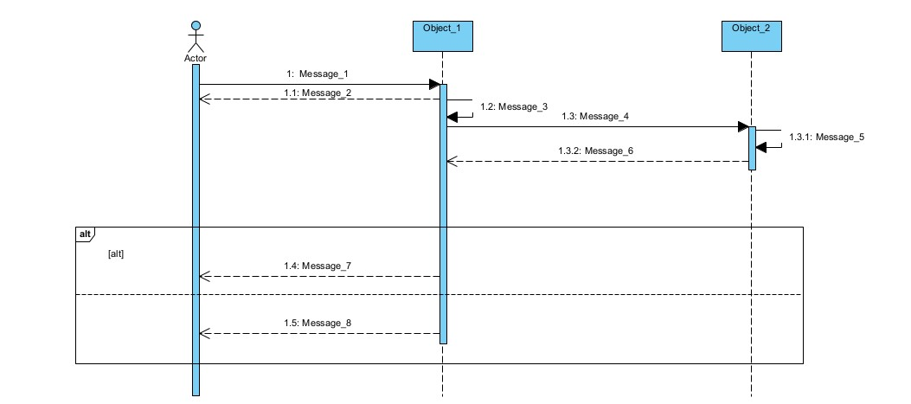

[

OK

]

[

NOT

Figure 11: Sequence Diagram Formalism

Table 18:Component of a Sequence Diagram

|  |  |  |
| --- | --- | --- |
| Element Representation Description | | |
| Lifeline |  | It represents the presence of an object over time in the execution of a modelled function. |
| Activation |  | It is used to represent a period during which an objective is active when a modelled use case is running |
| Message |  | Message are arrows that represent  communication between objects: Synchronous message: Message completed with feedback. Asynchronous message: Message complete without waiting for feedback. |
| Combined fragment |  | Used to group messages together to show conditional flow in a sequence diagram |

##### SEQUENCE DIAGRAM: AUTHENTICATE

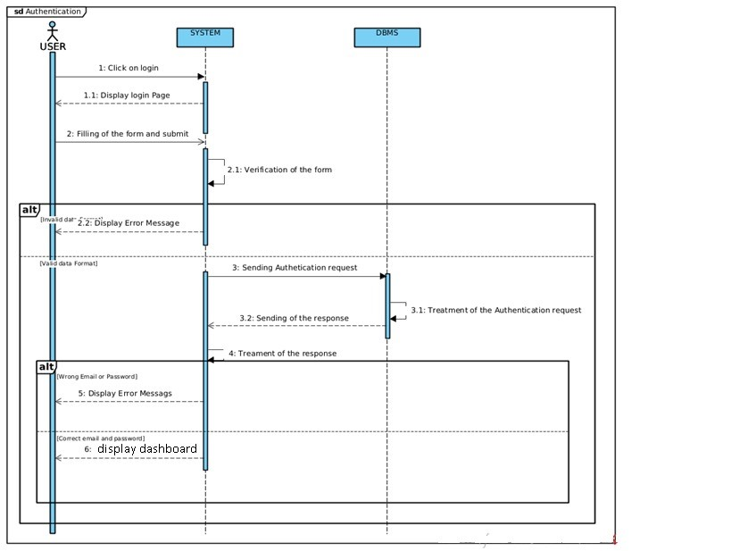

Figure 12: Authentication Sequence diagram

##### SEQUENCE DIAGRAM: Post Job

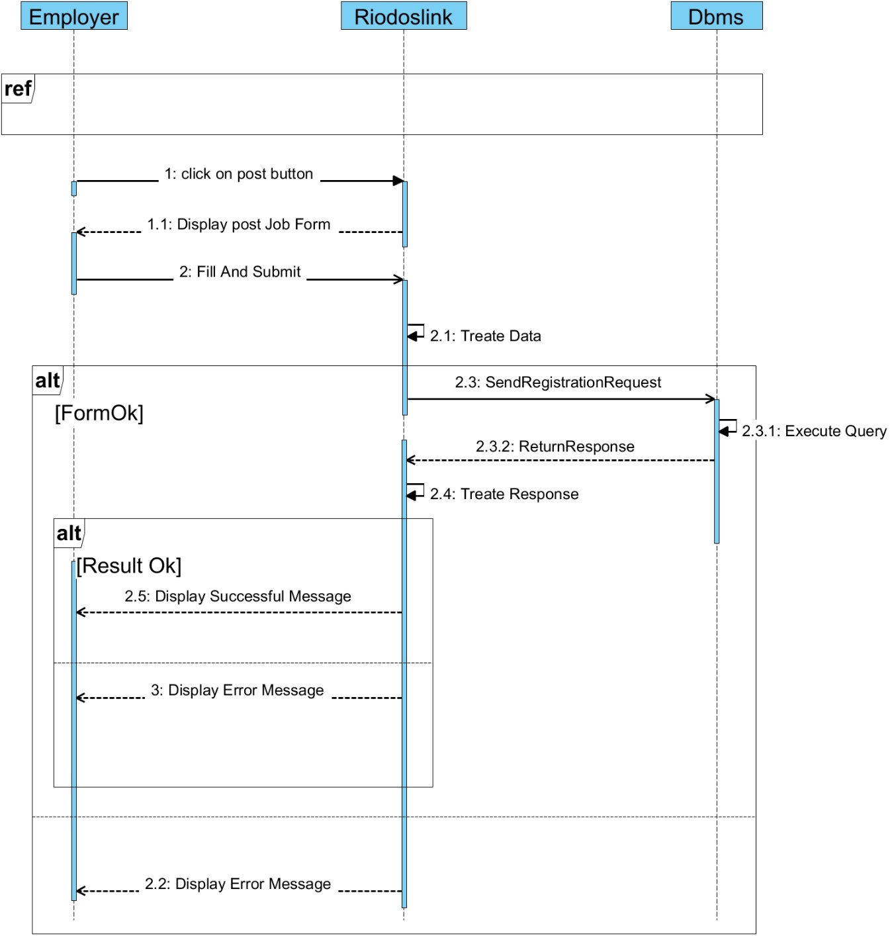

Figure 13: Post Job sequence diagram

##### d) ACTIVITY DIAGRAM

###### Definition

An activity diagram is a graphical representation of workflows that show the step needed in the realization of a process showing the details from start point to an end point through all the decision and actions that can possibly be performed. Activity diagrams are intended to model both the computational and organizational process. They show the overall flow, which is drawn from one operation to another. This flow can be sequential, branched or concurrent. Below is the activity diagram formalism.

Formalism*:*

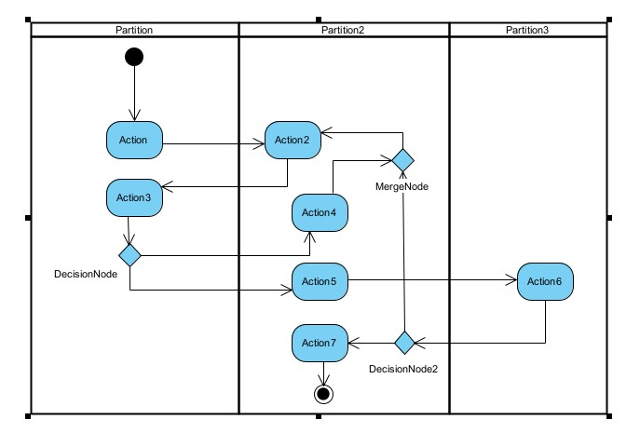

Figure 14: Activity Diagram Formalism

|  |  |  |
| --- | --- | --- |
| ELEMENT  DESCRIPTION | | NOTATION |
| Activity | An activity is shown as a rounded-concerned rectangle enclosing all the actions, control flow and all the element that make up the activity. |  |
| Action | It represents a single step within an activity. Actions are generally denoted by rounded cornered rectangles |  |
| Transition (Control Flow) | Control flows show the flow of control from one action to the next. It’s represented by a line with an arrow head |  |
| An Initial or Start node | It is depicted by a large black spot |  |
| Final Nodes | They are diamond shaped having control flows with guard conditions |  |
| Object Node | An object node is an activity node that indicate an instance of a particular classifier or a particular point in the activity |  |
| Swim Lanes | This is where we place activities. Items are listed inside it. |  |
| Flow Final node | This indicates the end of a flow |  |

*Table 19: Component of an Activity Diagram*

###### *ACTIVITY DIAGRAM: Post a Job*

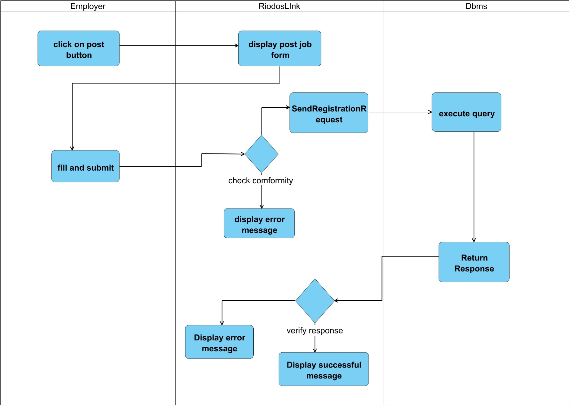

Figure 15: Activity diagram Post Job

### CONCLUSION

The Analysis document has enabled us to sort out the problem at hand, and then proposed a solution that will lead to the realization of RiodusLink. From here we will proceed to the conception phase where we shall see a detailed conception of the system.

# BOOK FOUR: CONCEPTION PHASE

Preamble

#### 

The conception phase is part of the document that shows the link between the analysis and the realization phase. It is a continuation of the analysis phase which represents the technical aspects used in modelling our system.

Content overview

Introduction

1. TECHNICAL BRANCH
2. CAPTURE TECHNICAL NEEDS
3. RELATED UML DIAGRAMS

Conclusion

## INTRODUCTION

The conception phase consists of defining the necessary components to the construction for the technical architecture. This conception is completely independent of the functional aspects. In this phase, we are going to see the technical branch of 2TUP which consist of technical needs and capture of the various UML diagrams that are going to permit us to model our system.

## I. TECHNICAL BRANCH

Generic Design.

### ***Hardware Diagram of the System***

The hardware diagram shows in details how the application components of our system are deployed through the adequate computer network. Below is the hardware diagram of our system



User 1

User

2

User

3



Main server

Database

server

Admin portal

Administrator

Internal domain

Firewall

External domain

*:*

Figure 17:Hardware Diagram of the system

### ***Physical Architecture of the System***

The physical architecture diagram shows the machines in which different application components of our system will be installed. We will use a n-tier achitecture

The tiers of our system include:

* The client tier, that runs on a mobile phone,
* The application tier, which runs on a Java web server;
* The data tier, that runs on a database server.
* The Gemini API

### ***Logical Architecture of the System***

To avoid a lack of maintainability, testability and scalability, which are drawbacks of the traditional approach of programming which works on Input-Processes-Output, we opted for the MVC architecture of our application. MVC is an Acronym for **Model View** and **Controller**. The MVC architecture is a design pattern that is used in software engineering to separate the application’s logic from the user interface. As the name implies, the MVC is described in three layers, namely:

* The Model (business logic and access to data);
* The View (user interface);
* The Controller (request handler) performs the action of invoking the Model and sending data to the View.

The MVC layers are independent from one another. A change in the content of one will have no effect on the others. This is a great advantage in that it facilitates maintenance and follow up of the software. Below are derails concerning the layers:

* **Model**: Model objects are the parts of the application that implement the logic for the application’s data land registry. Model objects retrieves and store model state in a database. The model itself can be sub divided into many levels but this decomposition is not shown at the MVC level
* **View:** The view has components that display the application’s user interface (UI).

It is the presentation layer used to display the Model data fetched by the controller.

* **Controller:** This layer acts as an interface between View and Model. It receives requests from the View layer and processes them, including the necessary validations. The request is further sent back to the Controller and then displayed on the View.

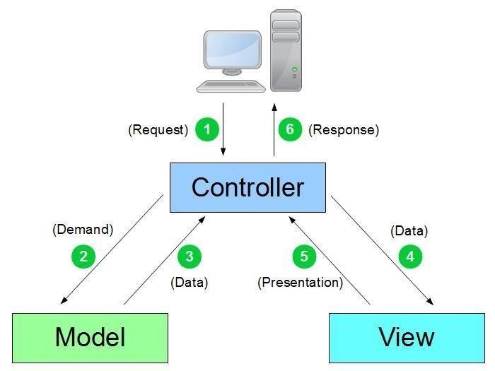

Figure 18: MVC pattern diagram

#### Advantages of MVC Design Pattern

* **Simultaneous development:** MVC architecture makes it possible for multiple developers to work simultaneously on the model, controller and views.
* **High cohesion:** MVC enables logical grouping of related actions on a controller together. The views for a specific model are also grouped together.
* **Low coupling:** The very nature of the MVC frame work is such that there is low coupling among models, views and controllers.
* **Ease of modification:** Because of the separation of responsibilities, future development or modification is easier, that is scalability of the product is increased.
* **Multiple views for a model**: Models can have multiple views.

## RELATED UML DIAGRAMS

#### A) Class Diagram

##### Definition

In UML, a class diagram is a type of static structure diagram that describe the structure of a system by showing the system’s classes, their attributes, their methods or operations and their relationship among objects. Classes are represented with boxes that contain three compartments:

* The top compartment containing the class name;
* The middle compartment containing the attributes of the class;
* The button compartment containing the operations the class can execute.

##### Formalism

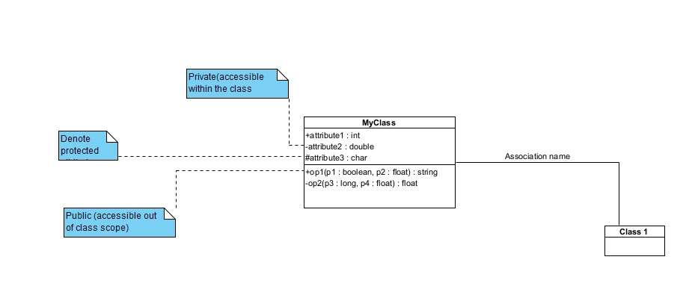

Figure 19: Class Diagram Formalism

Table 20:Component of a Class diagram

|  |  |  |
| --- | --- | --- |
| Element Representation Description | | |
| Inheritance or  Generalization |  | A  generalization is used to  indicate inheritance. It shows a parent class generalizing a child class |
| Association |  | It is the  general relationship type between elements. This connector may include named roles at each end,  cardinality, direction and attributes. |
| Aggregation |  | If the parent of aggregate is deleted, Usually the children are not deleted. |
| Composition |  | If the Parent of a composite is deleted, usually, all of its parts are deleted within it. | |
| Class |  | A class is an element that defines the attributes and behaviour that an object is able to generate. | |
| Dependency |  | Exists  between two classes if changes in the definition of one may cause changes to the other, but not the other way around. | |

##### Class Diagram

Figure 20: System class Diagram

###### B) State Machine Diagram

Definition

A state machine diagram describes the behaviour of a single object in response to a series of events in a system. Also known as the state chart diagram, it models the dynamic flow of control from the state of a particular object within a system.

Formalism

*:*

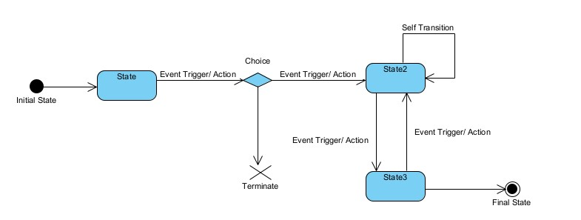

State Machine Diagram

Figure 21:Formalism of a state machine diagram

Components of State Machine Diagram

Table 21:Components of a State Machine diagram

|  |  |  |
| --- | --- | --- |
| ELEMENT | DESCRIPTION | NOTATION |
| States | A state is denoted by a rounded cornered rectangle with the name of the state written inside it. |  |
| Initiates states | The initial states is denoted by a field circle and may be labelled with name. |  |
| Transitions | Transitions from one state to the next are denoted by lines with arrow heads. A transition may have a trigger, a guard and an effect. |  |
|  |  |  |
| Junction | Junction vertices are semantic free vertices that are used to chain together multiple transitions. They are used to construct compound transition paths between states |  |
| Final states | The final state is denoted by a circle with a dot inside |  |

STATE MACHINE DIAGRAM: Application

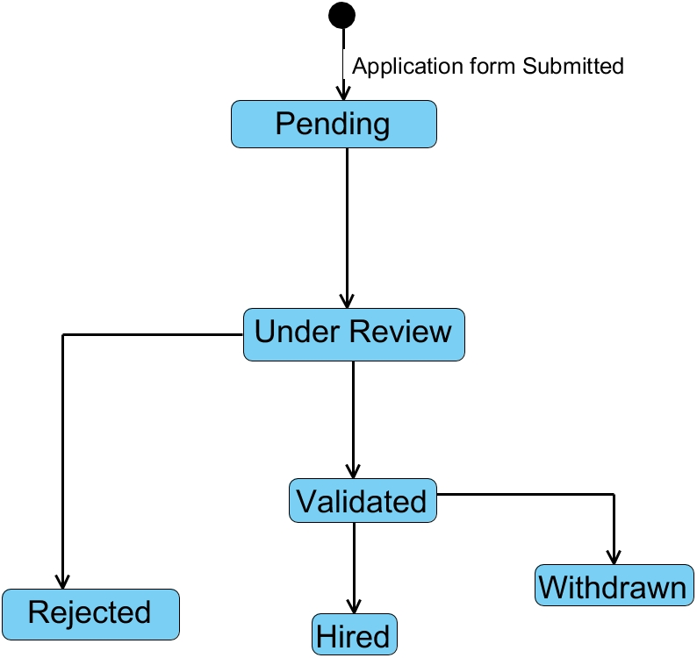

Figure 22: Post Job State machine diagram

#### C) Package Diagram

##### Definition

Package diagrams serve the purpose of reflecting the organization of package and their elements. When used to represent class element, package diagram provides a visualization of the namespaces. The most common use for package diagram is to organize use case diagram and class diagram although the use of package diagram is not limited to these elements.

##### Formalism

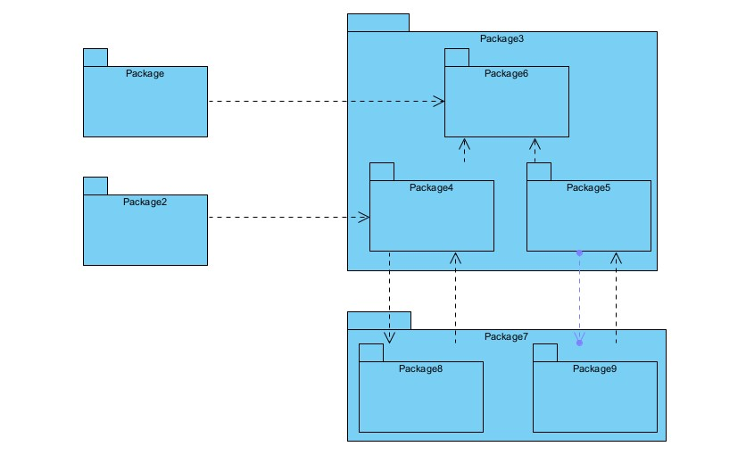

Figure 23: Formalism Package Diagram

Table 22:Package Diagram Formalism

|  |  |  |
| --- | --- | --- |
| Name Representation Description | | |
| Package |  | A package is a namespace used to group together elements that are semantically related and might change  together. It is a general-  purpose mechanism to organize elements into groups to provide a better structure for system model |
| Mo |  | It is a direct relationship between two packages that indicates that the content of the target (merged package) is combined into the source (receiving/merging package). |
| Package  Import |  | This is a direct relationship between an importing namespace and imported package, that allows the use of unqualified names to refer to the package members from other namespaces. |
| Package access |  | It is a direct relationship used to show that a UML element or a set of elements require(s) or depend(s) on another model element for  implementation |

Package Diagram

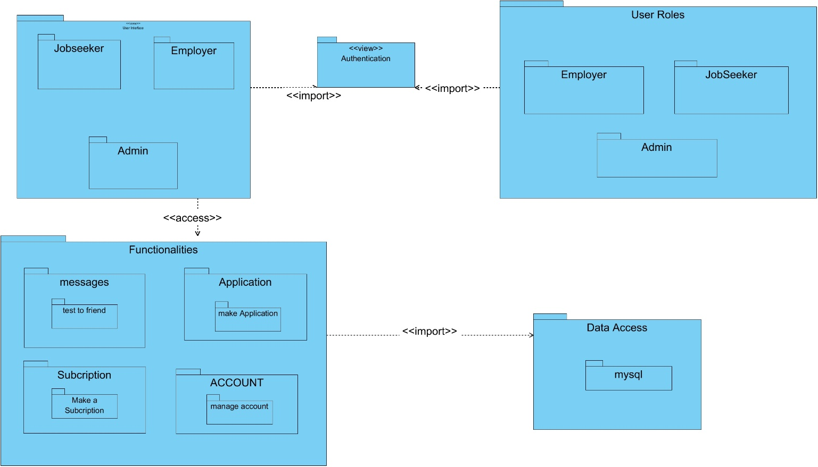

Figure 24: Package Diagram

## CONCLUSION

From the conception document, we have detailed the proposed solution for RiodusLink, outlining its structural, organizational, and technical components through models like UML diagrams. This phase establishes a clear framework for implementing a scalable, maintainable platform using Spring Boot for the backend and Next.js for the frontend, integrated with **MySQL** for data management. The next step will focus on the realization phase, where we will implement and test the solution to address the identified challenges in professional networking and job opportunities in Cameroon

# BOOK FIVE: REALIZATION PHASE

# BOOK FIVE: REALIZATION PHASE

Preamble

The realization phase contains the fact that are strongly related to the analysis phase and aim at the physical implementation of the software

Content overview

### 

INTRODUCTION

1. COMPONENT DIAGRAM
2. DEPLOYEMENT DIAGRAM
3. CHOICES OF TECHNOLOGIES

CONCLUSION

INTRODUCTION

The Realization phase focuses on the implementation of the job portal platform, transforming the design from the conception phase into a functional system. This phase involves coding, integration, and deployment of the platform to address the inefficiencies in the **job recruitment and employment market**. Using technologies such as **Spring Boot, Next.js, and MySQL**, the job portal was developed to provide a seamless experience for **job seekers, employers, and administrators**. This section details the development process, key modules implemented, and the deployment strategy, ensuring the platform meets the needs of the **modern employment ecosystem**.

### a) Component Diagram

##### Definition

A component diagram represents modular aspect of an object-orientated system that encapsulate their content and whose manifestation is replaceable within their environment. The modular aspect includes: run-time, executable and source code components.

##### Formalism

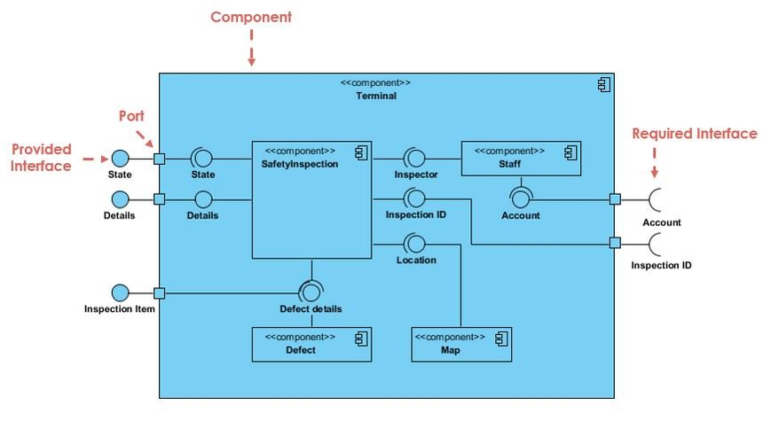

Figure 25:Component diagram formalism (https://www.visual-paradigm.com/guide/uml-unified-modeling-language/what-iscomponent-diagram)

Table 24: Formalism of a component Diagram

|  |  |  |
| --- | --- | --- |
| Name | Representation | Description |
| A component |  | A component is an abstract logical unit block of a system. It is represented as a rectangle with a smaller rectangle in the upper right corner with tabs, or the word written above the name of the  component |
| Dependency |  | Dependency is a directed relationship which is used to show that some component or set of components depend on other component elements for specification and implementation. It is represented with dashed arrows |
| Interface |  | An interface (small circle or semi-circle on a sick) describes a group of operation required or provided by components |

##### *Component Diagram*

Figure 26:Component Diagram

#### b) Deployment Diagram

##### Definition

The deployment diagram is a structural diagram that shows the architecture of a system as distribution of software artefacts to deployment targets. It involves modelling the hardware configuration together with the software component that live on them.

##### Formalism

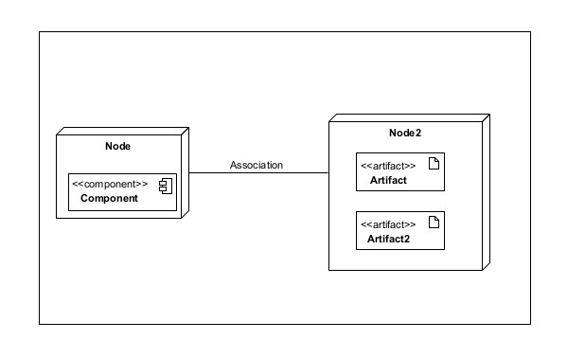

Figure 27: Formalism Deployment diagram

Table 25: Component of a Deployment Diagram

|  |  |  |
| --- | --- | --- |
| Elements | Representation | Description |
| Node |  | A node is either a hardware or a software |
| Artifact |  | An artifact is a product of a software development process or the operation of a system. |
| Component |  | It represents a modular part of a system that encapsulates its content and whose manifestation is replaceable within its environment |
| Association |  | An association represents a communication path between nodes. |

##### B) Deployment Diagram

*Figure 28: System deployment diagram*

# CHOICES OF TECHNOLOGIES

#### MATERIAL RESOURCES

Table 26: Material resources

|  |
| --- |
| HARDWARE RESOURCES |
| * HP Computer, Intel core i3 1TB , RAM 20GO * WIFI HOME BOX |

#### SOFTWARE RESOURCES

Table 27: Software resources

|  |  |  |  |
| --- | --- | --- | --- |
| SOFTWARE NAME | VERSION | USAGE | LOGO |
| OS window 10 | 18.32 | The operating system we worked on is Windows 10 |  |
| |  |  |  | | --- | --- | --- | | Vitual Paradigm |  |  | | 16,5 | The software engineering workshop used for solution modeling is called "Enterprise Architect." We utilized this tool to create various diagrams for our system modeling. |  |
| Visuel studio code | 1.93.1. | The text editor used to enter the lines of code that will be interpreted by the browser is called a "code editor." |  |
| Postman | 10.24 | It is a platform that aims to simplify every step of the API lifecycle and streamline collaboration, in order to create better APIs more easily and quickly |  |
| Laragon | 8.0.30 | It is the use the database management |  |

Technologies used for the development of the system

|  |  |  |
| --- | --- | --- |
| Image | Name | Spring boot |
|  | Java sprint boot | Backend development |
| download (3) | Framework Next.js | Front-end development |

# BOOK SIBX: TEST OF FUNTIONALITIES

Preamble

In this phase, we will present the various functionalities of RiodusLink, our digital platform for professional connections and job opportunities in Cameroon. This chapter focuses on demonstrating the core features of the platform, explaining how they benefit users, and how they support RiodusLink’s goal of streamlining job searches, applications, and professional networking.

Content overview

INTRODUCTION

1. LOGIN
2. REGISTER
3. CREATE BOOK
4. VIEW BOOK
5. BUY BOOK

CONCLUSION

INTRODUCTION

The test of functionalities phase evaluates the performance and usability of RiodusLink, our web-based platform for professional connections and job opportunities in Cameroon. This chapter highlights the core functionalities and modules of RiodusLink, detailing how each enhances the user experience and contributes to efficient job searches, applications, and professional networking.

**APPLICATION FUNCTIONALITIES**

1. **Authentication**

This functionality allows job seekers and employers to securely access their dashboards. Users can sign up for an account or log in with existing credentials.

1. **Receive Alerts**

Users receive important notifications about new job postings, application status updates, and interview schedules, ensuring job seekers stay informed about their applications and opportunities.

1. **User Management**

Employers can efficiently manage their job postings and applicants by adding, editing, and storing job details, applicant information, and interview schedules in the database. This enhances organization and improves hiring efficiency.

1. **Job Application Submission**

Job seekers can easily apply for positions directly through the platform. Employers can view, validate, and track applications, streamlining the hiring process**.**

1. **Job Posting Management**

Employers can create, update, and manage job postings, including details such as job title, description, requirements, and application deadlines. This allows for effective job visibility and management.

1. **Profile Management**

Users (job seekers and employers) can edit their profile details, such as name, email, phone number, and LinkedIn profile. This feature enables users to keep their information current and improve networking opportunities.

1. **Notifications**

Job seekers receive notifications regarding their application status, new job matches based on their profile, and reminders for upcoming interviews. This keeps users engaged and informed.

1. **Application Insights**

Employers can analyze applicant data and monitor overall application statuses. This functionality provides insights into hiring patterns, candidate demographics, and application trends to enhance recruitment strategies.

* + - 1. API test for Post Jobs

Endpoint: post / api/employers/jobs

Method: Post



Purpose: This endpoint is used to get all the jobs

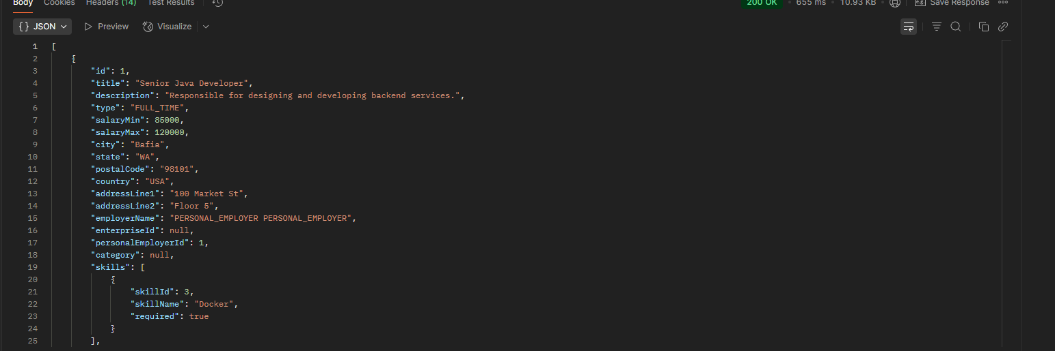

Figure 29 Api For Create Job

* + - 1. Get Clients API Test

Method: GET



Endpoint: GET /api/v/auth/applications/all

Purpose: Fetch a list of Applications

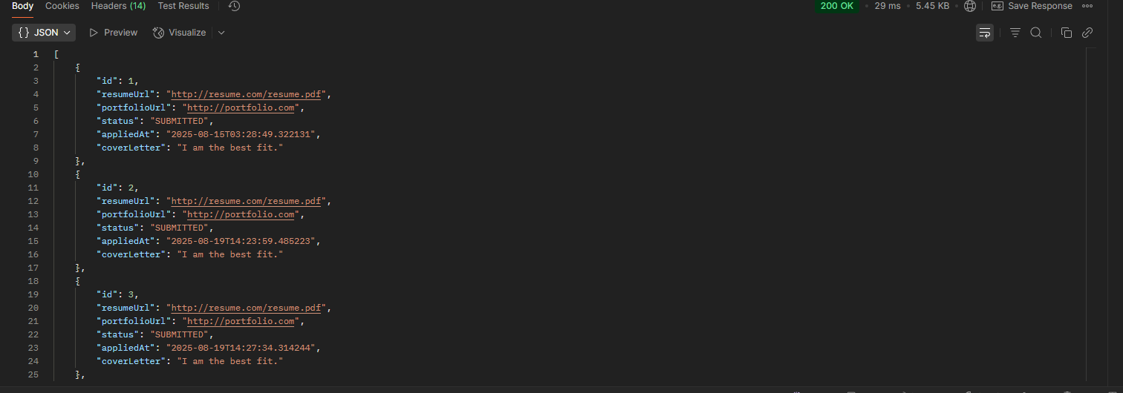

Figure 30: Api TO Get All Jons

### CONCLUSION

Having put in place the platform, it was not sufficient for we had to produce a manual that will help its various users. That is why we presented the different tools to be installed and how they are to be installed in order to run this application without any problem and how the users will use this platform once the environment is set up.

# BOOK SEVEN: USER GUIDE

Preamble

This phase actually aims at show the installation process of the application and how it functions.

Content Overview

INTRODUCTION

1. INSTALLATION GUIDE
2. USER INTERFACE GUIDE

CONCLUSION

## INTRODUCTION

The user guide is the final phase of our report. In this phase, we will walk through the requirements for using our system, the necessary installation processes and accessing our system and its features, all this in a step-by-step manner to facilitate the setting up of the system for first-time users. The steps of the different processes will be accompanied by visuals. After the processes involving setting up our system, we will go through a showcase of the key functionalities our system offers.

WEB Application

To be able to use RiodusLink web application, just connect to the internet and navigate to the website to either create an account or login.

* + - 1. 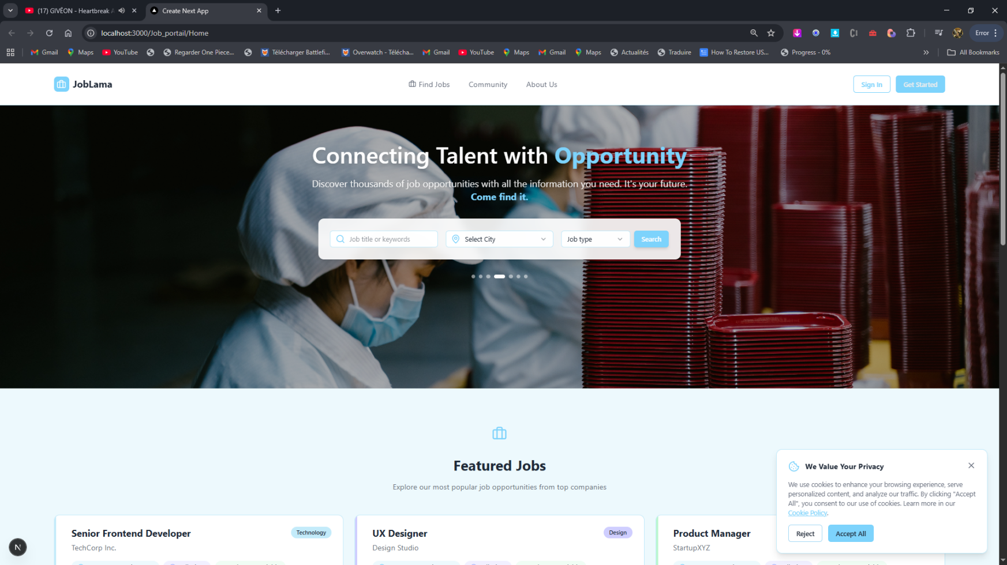SHOW CASES

Figure 31: RiodusLInk Welcome Screen

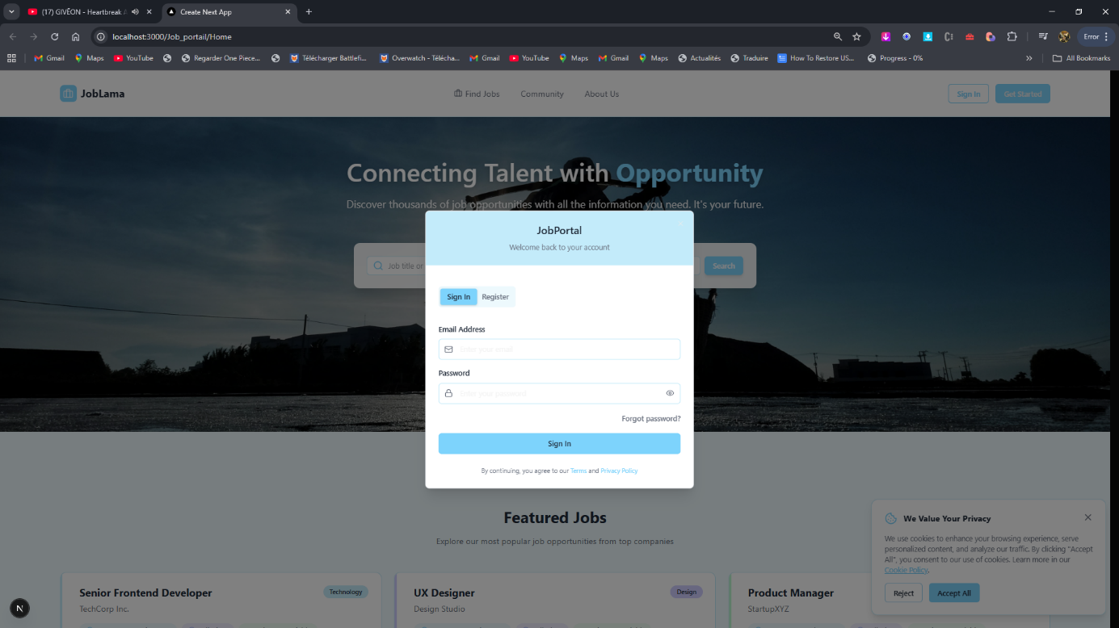

Figure 32: Login Page

**4. Key Functionalities**

**1. JOB POSTING**

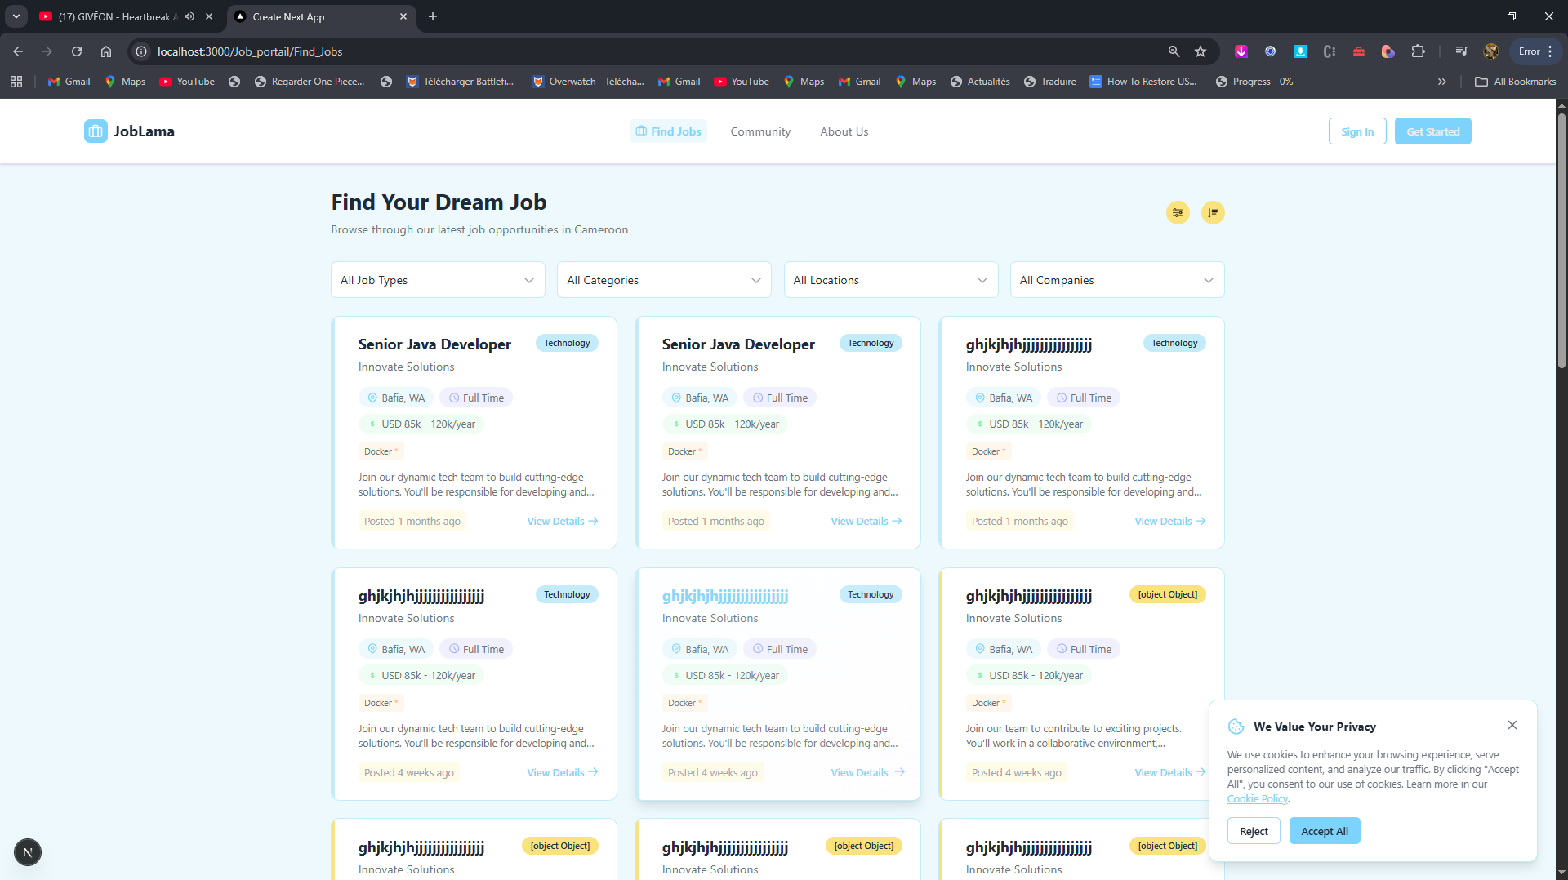

Figure 33: All Jobs

##### CONCLUSION

Having put in place the platform, it was not sufficient for we had to produce a manual that will help its various users. That is why we presented the different tools to be installed and how they are to be installed in order to run this application without any problem and how the users will use this platform once the environment is set up.

## PERSPECTIVES

To enhance your application, focus on improving user experience through better navigation, customizable dashboards, and real-time updates. Expand functionality by integrating advanced filtering, AI-driven insights, and a profile completion meter. Optimize the back-end with API enhancements, database optimization, and robust security measures, while implementing monitoring and logging for performance tracking. Leverage the existing admin section to streamline enterprise verification and application tracking processes. Ensure code quality through refactoring, comprehensive testing, and thorough documentation to maintain scalability and readability. These measures will significantly improve usability, functionality, and maintainability of the application. enhance user experience and improve operational efficiency. One key feature is **AI-driven job matching**, which leverages machine learning algorithms to analyze user profiles and job postings, suggesting the best job matches for candidates based on their skills, experiences, and preferences. This personalization can significantly increase the chances of successful placements, benefiting both job seekers and employers.

# GENERAL CONCLUSION

The RiodusLink platform developed in this project aims to streamline the hiring process for employers while enhancing the job-seeking experience for candidates in Cameroon. By integrating functionalities such as user authentication, job posting management, and application tracking, RiodusLink creates a user-friendly environment that supports efficient interactions between job seekers and employers. Real-time notifications and application insights ensure both parties remain informed and engaged throughout the hiring journey, promoting a more effective recruitment process. The platform emphasizes robust data management and user experience, leveraging modern technologies like Spring Boot for a scalable backend and Next.js for a responsive frontend, integrated with MySQL for efficient data storage and retrieval. Key features, including profile management, appointment scheduling, and AI-driven job matching, address the immediate needs of users while providing analytics for continuous improvement. Ultimately, RiodusLink positions itself as a comprehensive solution in the competitive landscape of job recruitment platforms, fostering professional connections and driving successful employment outcomes in Cameroon.

# BIBLIOGRAPHY

Author not listed. *Méthode d’Etude et de Réalisation Informatique pour des Systèmes d’Entreprise (MERISE)*.

Alistair Cockburn. *Agile Software Development: The Cooperative Game*. Addison-Wesley, 2nd Edition, 2006.

Schwaber, Ken. *Agile Project Management with Scrum*. Microsoft Press, 2004.

Ivar Jacobson, Grady Booch, James Rumbaugh. *The Unified Software Development Process*. Addison-Wesley, 1999.

Fowler, Martin. *UML Distilled: A Brief Guide to the Standard Object Modeling Language*. Addison-Wesley, 3rd Edition, 2003.

GLOSSARY

* + 1. **API (Application Programming Interface):** A set of rules and tools for building software and allowing different applications to communicate with each other.
    2. **Backend:** The server-side of an application, where data is stored, processed, and managed. It includes the server, database, and application logic that support the app's functionality.
    3. **CV (Curriculum Vitae)**: A document that summarizes a person's educational background, work experience, skills, and accomplishments, used for job applications.
    4. **Database Management System (DBMS)**: Software that interacts with the database to manage data storage, retrieval, and manipulation.
    5. **Job Application**: The process where candidates submit their CVs and other required information to be considered for a job position.
    6. **Job Posting**: An advertisement created by employers that describes a job opportunity, including its responsibilities and qualifications.
    7. **3-tier Architecture:** A software architecture model where the application is separated into 3 logical layers, usually including the presentation (frontend), application logic (backend), and data storage (database) tiers.
    8. **UI (User Interface):** The visual elements that users interact with on an application, such as buttons, forms, and menus.
    9. **UX (User Experience):** The overall experience and satisfaction a user has when interacting with an application, including how easy and intuitive it is to use.

# WEBOGRAPHY

* "Visual Paradigm UML Guide". Accessed from <https://www.visual-paradigm.com/guide> . Accessed on: 12/07/2024 at 10:45am
* "UML 2.5 Diagrams Overview". UML Diagrams Website. Accessed from <http://www.uml-diagrams.org> . Accessed on: 28/07/2024 at 9:30am
* "Realize Cameroon". Company website and resources. Accessed from <https://www.realize-cm.com> . Accessed on: 17/08/2024 at 10:00am
* "Spring Boot Documentation". Spring Official Site. Accessed from <https://docs.spring.io/spring-boot/docs/current/reference/html> . Accessed on: 06/09/2024 at 9:00am
* "Next.js Documentation". Next.js Official Site. Accessed from <https://nextjs.org/docs> . Accessed on: 06/09/2024 at 9:15am
* "MySQL Documentation". MySQL Official Site. Accessed from <https://dev.mysql.com/doc> . Accessed on: 06/09/2024 at 8:45am
* "Scrum Framework Overview". Scrum.org. Accessed from <https://www.scrum.org/resources/what-is-scrum> . Accessed on: 06/09/2024 at 10:45am
* "Tailwind CSS Documentation". Tailwind CSS Official Site. Accessed from <https://tailwindcss.com/docs> . Accessed on: 20/09/2024 at 10:00am

.

.

# ANNEX

# CONTENT

DEDICATION i

ACKNOWLEDGEMENTS ii

ABSTRACT iii

RESUME iv

SUMMARY v

LIST OF FIGURES vi

LIST OF TABLES vii

GENERAL INTRODUCTION 1

PART ONE: INSERTION PHASE 3

INTRODUCTION 5

WELCOME AND INTEGRATRION 6

GENERAL PRESENTATION OF THE COMPANY 7

CONCLUSION 12

PART TWO: TECHNICAL PHASE 13

BOOK ONE: EXISTING 14

**INTRODUCTION** 16

I. DESCRIPTION OF THE EXISTING SYSTEM 18

II. LIMITS OF THE EXISTING SYSTEM 20

III. PROBLEMATIC 21

IV. PROPOSED SOLUTION 22

V. DELIMITATIONS OF THE FIELD OF STUDY 23

BOOK TWO: SPECIFICATION PHASE 25

INTRODUCTION 27

V. ESTIMATED COST OF PROJECT 35

VI. ESTIMATION OF TIME REQUIRED 38

VII. CONSTRAINTS 40

VIII. LIST OF PARTICIPANTS AND DELIVERABLES 40

CONCLUSION 42

BOOK THREE: 43

ANALYSIS PHASE 43

Preamble 44

INTRODUCTION 45

VI. PRESENTATION OF THE ANALYSIS METHOD 46

VII. CHOICE OF THE ANALYSIS APPROACH 48

VIII. MODELING OF THE PROPOSED SOLUTION 53

Use case: Manage application 57

Use case: Post Job Openings 58

Use case: Apply for Jobs 59

TEXTUAL DESCRIPTION OF Post Job Openings 64

Post Job communication diagram 69

CONCLUSION 80

BOOK FOUR: CONCEPTION PHASE 81

INTRODUCTION 83

I. TECHNICAL BRANCH 84

***Hardware Diagram of the System*** 84

***Physical Architecture of the System*** 84

***Logical Architecture of the System*** 85

RELATED UML DIAGRAMS 87

Package Diagram 97

System object diagram 100

CONCLUSION 101

BOOK FIVE: REALIZATION PHASE 102

Preamble 103

Content 103

a) Component Diagram 104

c) CHOICES OF TECHNOLOGIES 110

3.LANGUAGE USED 111

BOOK SIX: TEST OF FUNTIONALITIES 113

CONCLUSION 116 117

BOOK SEVEN: USER GUIDE 117

Preamble 118

Content 118

INTRODUCTION 119

PERSPECTIVES 126

GENERAL CONCLUSION 127

BIBLIOGRAPHY ix

WEBOGRAPHY xi

ANNEX xii

CONTENT xiii